YESHWANT MAHAVIDYALAYA, WARDHA
Internal Quality Assurance Cell (IQAC)

NOTICE

All the members of IQAC are hereby requested to attend the meeting of IQAC on Tuesday,4 July 2020 at 11.15 a.m. in Room No.8 to discuss the following agenda:
- Confirmation of the minutes of the previous meeting
- Preparation of academic calender
- Execution of Academic Calendar (online )
- Preparing of Teaching Plan
- Attending online webinar
- Online classes
- Any other subject with the permission of the chair
Date: 04 /07/2020
Yours Sincerely
Dr.K.C. Kulkarni
Coordinator, IQAC

YESHWANT MAHAVIDYALAYA, WARDHA
Internal Quality Assurance Cell (IQAC) Minutes of the meeting
The meeting of IQAC held on 04 /07/2020 , at 10.30 a.m. in the office of IQAC.
1 Confirmation of the minutes of the previous meeting: Dr. Kalpana Kulkarni, coordinator IQAC read out the minutes of previous meeting held on 5/02/2020

2 Preparation of academic calender: It is resolved to prepare Academic calendar of the various Department of the college for the session 2020-21
Action Taken: - All head of the departments instructed to prepare Academic calendar of the respective Departments for the session 2020-21.

3 Execution of Academic Calendar (online ): Discussion about execution of Academic calendar of the various Department of the college for the session 2020-21
Action Taken: - All head of the departments discussed about the actual execution of Academic calendar of the respective Departments for the session 2020-21.

- Preparing of Teaching Plan: It is resolved to prepare Teaching plan of the various Department of the college for the session 2020-21
Action Taken: - All head of the departments prepared Teaching plan of their respective subjects in the Department for the session 2020-21.

- Attending on webinar: all teaching staff motivated to attend maximum webinar and FDP to update knowledge
Action Taken: Teaching staff started attending webinar .
- Online classes: All teachers instructed about online classes.
Action Taken: Teacher staff started to prepare study material for online classes of their respective subject
Date: 04 /07/2020
Dr.K.C. Kulkarni
Coordinator, IQAC
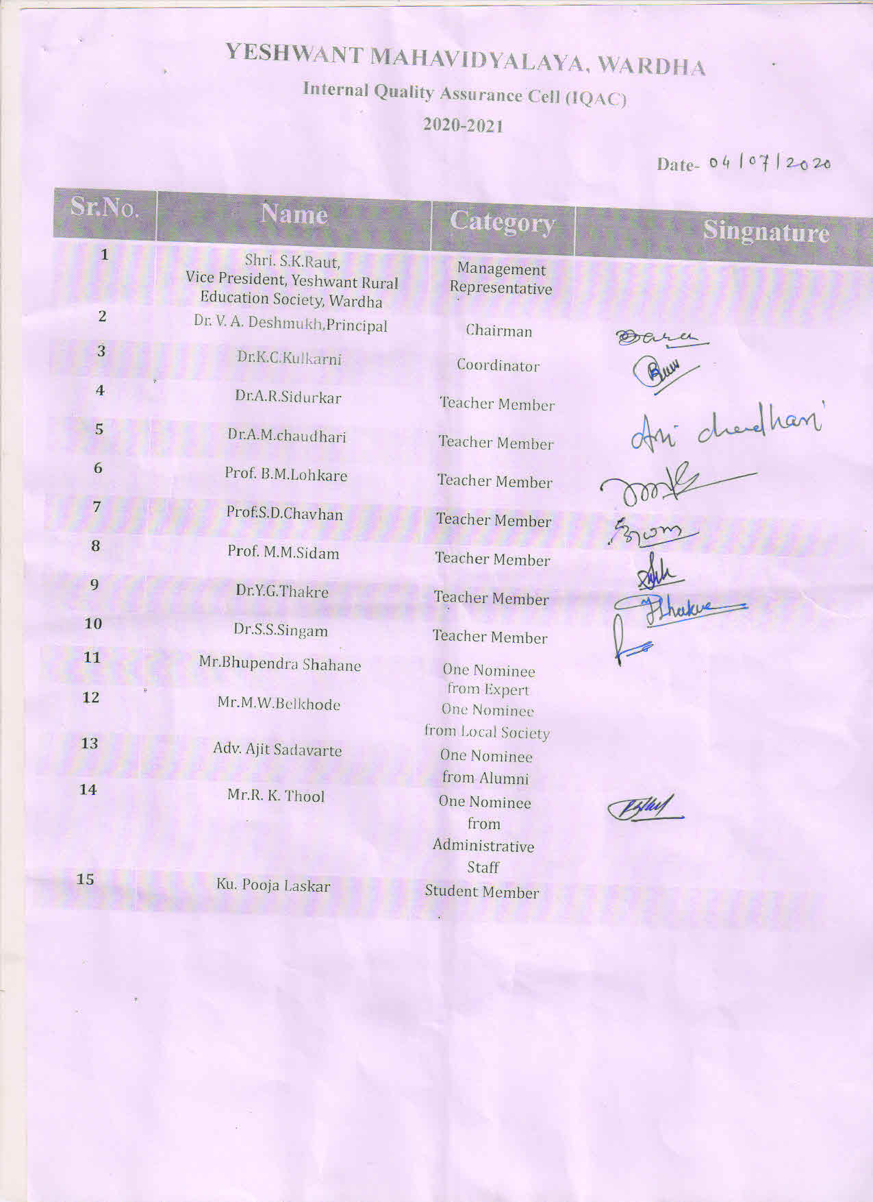

YESHWANT MAHAVIDYALAYA, WARDHA
Internal Quality Assurance Cell (IQAC)

NOTICE

All the Faculty members are hereby requested to attend the meeting of IQAC on Tuesday,13 Oct 2020 at 11.00 a.m. in Room No.8 to discuss the following agenda:
1 Confirmation of the minutes of the previous meeting
2 Execution of Academic Calendar (online )
3 Creating Google classroom
4 Conducting classes on Google meet
5 Attending FDP on LMS
6 Online evaluation
7 Remedial online coaching
8 Submission of AQAR 2019-20
9 Any other subject with the permission of the chair
Date: 13 /10/2020
Yours Sincerely
Dr.K.C. Kulkarni
Coordinator, IQAC

YESHWANT MAHAVIDYALAYA, WARDHA
Internal Quality Assurance Cell (IQAC)
Minutes of the meeting
The meeting of IQAC held on 13 /10/2020 , at 10.30 a.m. in the office of IQAC.
- Confirmation of the minutes of the previous meeting Dr. Kalpana Kulkarni, coordinator IQAC read out the minutes of previous meeting held on 04 /7/2020

- Execution of Academic Calendar (online): It is resolved that all faculty members should execute the online Academic calendar 2020-21in their respective departments by planning various activities supporting student .
Action Taken: - all faculty members planned to execute the Academic calendar 2020-21 in their respective departments,such as competitions,

- Creating Google classroom: All faculty members informed to create google class room of their respective subjects to opt asynchronized method of learning and aware students about this new platform of digital online learning
Action Taken: All faculty members created google class room of their respective subjects to provide study material ,audio video clips and informed students about this mode of Teaching -Learning

- Conducting classes on Google meet: All faculty members informed to opt synchronized learning by conducting classes on Google meet of their respective subjects.
Action Taken: All faculty members Conducted classes on Google meet of their respective subjects to have interactive communication with students

- Attending FDP on LMS: All faculty members are motivated to attend FDP on LMS .
Action Taken: All faculty members actively participated in FDPs on Learning Management System to get acquiescent to make virtual learning effectively

- Remedial online coaching : All head of the departments informed to conduct Remedial online coaching classes in their respective departments.
Action Taken: All Head of the departments prepared plan to conduct Remedial online coaching classes in their respective departments to help week students.
- Submission of AQAR 2019-20: All IQAC members are asked to collect criterion wise data for the Submission of AQAR 2019-20

Action Taken: All IQAC members are collected criterion wise data for the Submission of AQAR 2019-20
Date: 13 /10/2020 Dr.K.C. Kulkarni Coordinator, IQAC

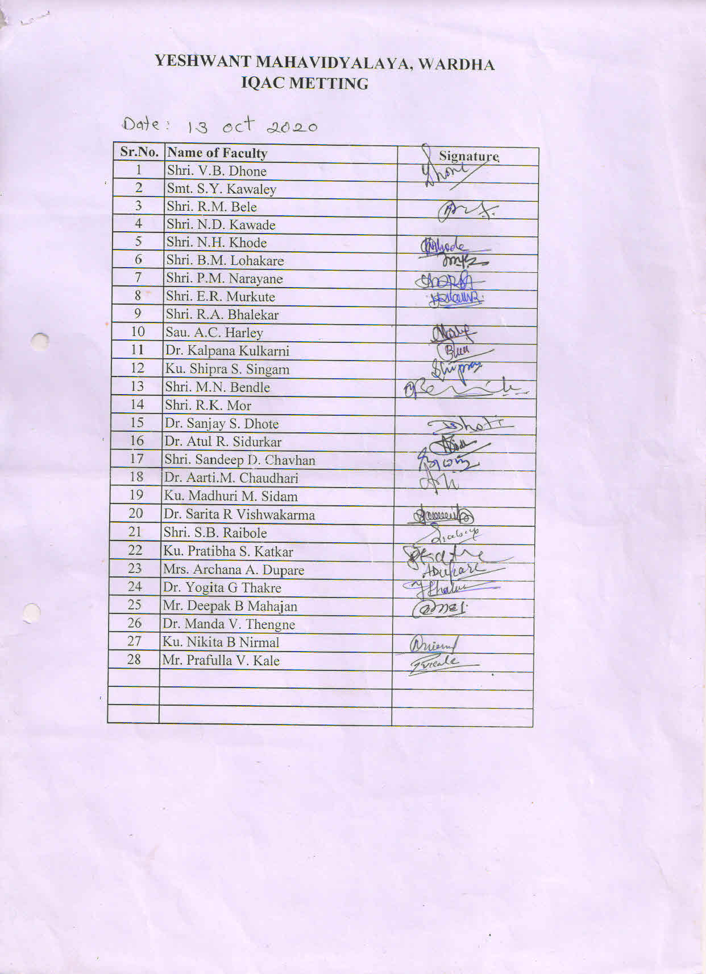

YESHWANT MAHAVIDYALAYA, WARDHA
Internal Quality Assurance Cell (IQAC)

NOTICE

All the members of IQAC are hereby requested to attend the meeting of IQAC on Tuesday, 7/01/ 2021 at 11.00 a.m. in Room No.8 to discuss the following agenda:
1 Confirmation of the minutes of the previous meeting
2 To organize online conference
3 Setting of question bank
4 Conducting online mock test for students
5 Use of all online platforms for teaching learning
6 Attending FDP on ms office,power point etc.
7 Online setting of university question papers
8 Submission of AQAR 2019-20
9 Any other subject with the permission of the chair
Date: 7 /1/2021
Yours Sincerely
Dr.K.C. Kulkarni
Coordinator, IQAC

YESHWANT MAHAVIDYALAYA, WARDHA
Internal Quality Assurance Cell (IQAC)
Minutes of the meeting
The meeting of IQAC held on 7 /1/2021 at 10.30 a.m . in the office of IQAC
- Confirmation of the minutes of the previous meeting :Dr. Kalpana Kulkarni, coordinator IQAC read out the minutes of previous meeting held on 13 /10/2020.

- To organize online conference: It is resolved that all Head of the departments instructed to organize online conference in their respective departments.
Action Taken: all head departments prepared the proposals for online conference in their respective departments.

- Conducting online mock test for students: It is resolved that all faculty members should instructed to conduct online mock test for students in their respective subjects.
Action Taken: all faculty members conducted online mock test for students in their respective subjects,to make them aware about new pattern of online test by RTMNU

- Attending FDP on ms office,power point etc.: All faculty members are instructed to attend FDP on LMS etc.
Action Taken: Faculty members attended FDP on managing online classes and creating e content..

- Online setting of university question papers and Question bank : Setting of Question bank and setting of university question papers as per the directions of RTMNU.
Action Taken: Dr.Kulkarni suggested that faculty member should prepare their own Question bank for students Faculty members in BOS should submit university question papers as per the directions of RTMNU within time limit.

- Submission of AQAR 2019-20: All IQAC members are instructed to collect criterion wise data for the Submission of AQAR 2019-20
Action Taken: All IQAC members are collected criterion wise data for the Submission of AQAR 2019-20
Date: 7 /1/2021 Dr.K.C. Kulkarni
Coordinator, IQAC
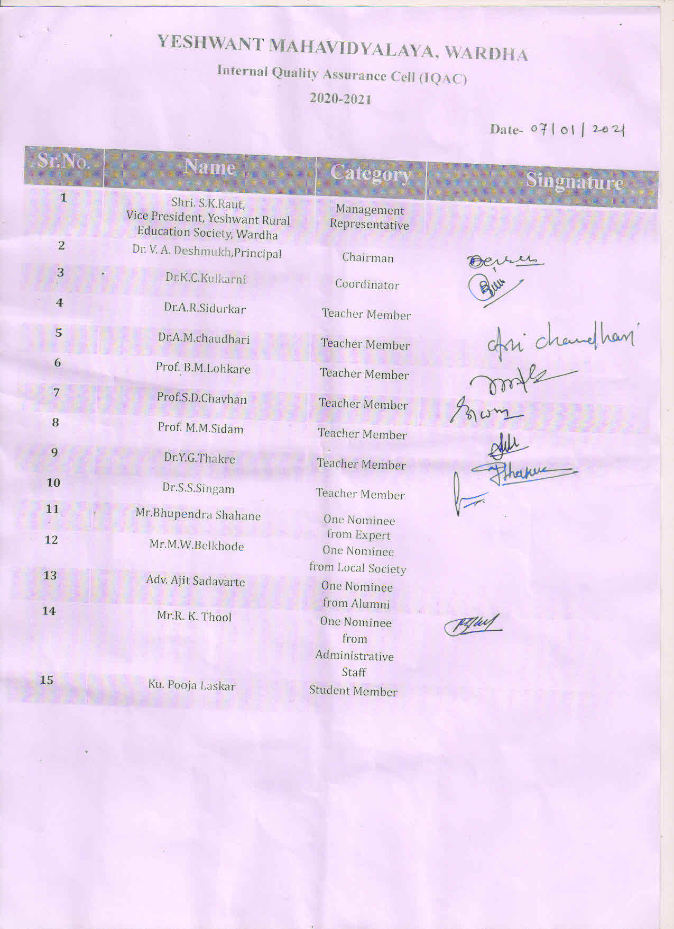

YESHWANT MAHAVIDYALAYA, WARDHA
Internal Quality Assurance Cell (IQAC)

NOTICE

All the members of IQAC are hereby requested to attend the meeting of IQAC on Tuesday,10/03/ 2021 at 11.00 a.m. in Room No.8 to discuss the following agenda:
- Confirmation of the minutes of the previous meeting
- To organize online conference
- Setting of question bank under BOS
- Conducting online unit test/quiz for students
- Use of all online platforms for teaching learning
- Attending FDP on ms office,power point etc.
- Online setting of university question papers
- Any other subject with the permission of the chair
Date: 10 /3/2021
Yours Sincerely
Dr.K.C. Kulkarni
Coordinator, IQAC

YESHWANT MAHAVIDYALAYA, WARDHA
Internal Quality Assurance Cell (IQAC) Minutes of the meeting
The meeting of IQAC held on 10 /3/2021, at 10.30 a.m. in the office of IQAC.

- Confirmation of the minutes of the previous meeting: Dr. Kalpana Kulkarni, coordinator IQAC read out the minutes of previous meeting held on 04 /07/2020.

- To organize online conference: It is resolved that all departments prepare a proposal of online conference.
Action Taken: All head of department prepared a proposal for online conferences.

- Setting of question bank under BOS

- Conducting online unit test/quiz for students: It is resolved that all departments prepare online unit test/quiz for students
Action Taken: All head of department conducted online unit test/quiz for students.

- Use of all online platforms for teaching learning: It is resolved that all departments should use online platforms for teaching learning.
Action Taken: All teaching staff started using online platforms for teaching learning.

- Attending FDP on ms office, power point etc.: All faculty members are instructed to attend FDP on ms office,power point etc.
Action Taken: All faculty members attended FDP ms office,power point etc.

- Online setting of university question papers: It is resolved that subject teacher participate in Online setting of university question papers as per the directions of RTMNU.
Action Taken: Faculty members participated in Online setting of university question papers as per the directions of RTMNU.
Date: 10 /3/2021 Dr.K.C. Kulkarni
Coordinator, IQAC

