Best Practice –I

- Title :- Activities Undertaken by Yeshwant StaffClub

- Goal: - Yeshwant Staff club, Wardha was established in the year 1968 by Prof. G.B. Kadam who was the Principal of the college and had served in the military forces and, later on, went on to become the Vice-Chancellor of Nagpur University, Nagpur. This club was started with several aims in the mind. The objectives of starting the club are givenbelow:-
  - To develop the academic orientation of thefaculty.
  - To boost the morale of the faculty and motivate them in the field ofresearch.
  - To create a congenial homely atmosphere among the management, the Principal and the teaching and non-teachingfaculty.
  - To felicitate the meritorious children of thefaculty.
  - To felicitate the incoming and outgoing faculty, and welcome newly married brides / bridegrooms into Yeshwantfamily.

- The Context: - Principal G.B. Kadam wanted every faculty member to work as a family member so that everyone would be sincere, committed and devoted to his work. Moreover, inclusion of new brides / bridegrooms in Yeshwant family would give them a new exposure and instil in them a confidence that their spouse is working in a healthy and congenial atmosphere. An employee working in such an atmosphere would not only get the job satisfaction; but also would be sincere and committed to thework.

- The Practice: - Yeshwant Staff Club organizes several activities befitting the staff members. Foremost among them is the practice of reading out a research / informative paper on every Wednesday. The paper reading programme begin with a medical health awareness programme. Teachers are given advance information regarding the dates of paper reading programme. The title and theme of paper is displayed on the notice board and on muster. After the paper presentation, there is a lively discussion. Arguments and counter-arguments are made for and against the paper. It becomes the duty of the paper reader to defend the ideas or the principles which he has propounded. Thus the paper reader comes to understand the shortcomings of his paper, moreover he gets a better insight and perception to develop his ideas as the paper has been discussed among all the staff members. This exercise can also instil confidence in the paper reader. The staff club also runs an activity wherein the incoming and outgoing faculty is felicitated. Moreover, the faculty members who are awarded Ph.D. degree, faculty getting appointed on important posts, awards and social recognition are felicitated in the programme. The newly married couples are also felicitated at the hands of the management. All the retired faculty along with their families are also invited for this programme. The staff club arranges two such programmes every year which are followed bydinner

- Evidence of Success: - The activity, run by Yeshwant Staff club, Wardha, instils a sense of confidence among the teaching and non-teaching faculty. It also gives job satisfaction. Moreover, the spouses come to have a confirmed opinion that the institution is like a big family wherein there is love, affection and ‘fellow feeling’.He
/ She is ready to allow him / her to spare more time in such a cosy atmosphere. Such a congenial atmosphere gives a sense of job satisfaction to the employees and they become sincere and devoted to the institution. Even the Management authorities freely interact with the families of the staff members giving the whole gathering a homely atmosphere. The success of the practice can be seen in the commitment and devotion of the employees for theirwork.

- Problems encountered and resource required: -The teaching staffs voluntarily contribute a fund for these activities, and as it is their own activity we don’t encounter any problems in runningit.

FuturePlan:

- To conduct a survey of the problems faced by the village, which is annually adopted by the college unit of NSS.
- To prepare a research paper based on survey to be presented in the regular staff club paper reading programmes.
- To submit the findings of the survey to district collector for necessary action.
- To work with local NGO for survey and find out remedial solution on it,which will be discussed in paper reading session.

Yeshwant Mahavidyalaya, Wardha
Staff Club
Session 2020-2021
Activity Organised Report

Co-ordinator
P. M. Narayane

Yeshwant Mahavidyalaya, Wardha
Staff Club Committee
Session 2020-2021

1 | Prof. Pramod M. Narayane | Co-ordinator
2 | Dr. Ravindra M. Bele | Member
3 | Prof. Aruna C. Harle | Member
4 | Prof. Pratibha Katkar | Member
5 | Prof. Suchita Raipure | Member
6 | Prof. Pranali Hiwarkar | Member
7 | Prof. Dipak Mahajan | Member
8 | Prof. Prafulla Kale | Member

Yeshwant Mahavidyalaya, Wardha
Staff Club
Session 2020-2021
Activity Organised Report

Following Programmes were conducted by Staff Club in session 2020-2021

Health awarnes Programe
Sr. No | Date | Name of Programe and Topic | Guest and chair Person
1 | 04 November 2020 | Online  Health awareness Programme | Dr. Akash Lohkare, MD, DM Wardha  Chair Person – Dr. V. A. Deshmukh Principal Yeshwant Mahavidyalaya, Wardha  Topic -  Use your heart to treat heart problems in Covid times.

Paper reading Programme

Sr.  No. | Date | Name of the Reader | Topic of the paper
1. | 2. 12.2020 | Dr. Arati Choudhari | Eco- Friendly Technology For Green India
2. | 16. 12. 2020 | Kiran Kale | Koronakal and Sharirik Swasthya
3. | 23. 12.2020 | Archana Dupare | Waste Management
4. | 20. 01.2021 | Dr. Yogita Thakare | Water Treatment For Domestic and Industrial Purpose
5. | 27. 01. 2021 | Amar Dahane | Gramin Bhagatil Pinyachya Pani Vyavastheche Arthik Adhyayan
6. | 03. 02. 2021 | Deepak Mahajan | Upekshit Samajatil Mahan Sant Chokhamela
7. | 10. 02. 2021 | Dr. Manda Thengane | Krida Kshetra Me Vyavsahik Sandhiya
8. | 03. 03. 2021 | Nikita Nirmal | Moukhik Sanskriti Aur Janjatiya Kala
9. | 10. 03. 2021 | Prafull Kale | Talvadya : Layatatwache Prabhavi Madhyam

Yeshwant Mahavidyalaya, Wardha
Staff Club
Activity Organised Report
Session 2020-2021

Name of the activity organized | Health avernass Programe
Title of the Paper | Use your heart to treat heart problems in Covid times.
Name of the paper reader | Dr. Akash Lohkare, Wardha
Date of activity organized | 04 November 2020
Name of the chairperson | Principal Dr. V. A. Deshmukh
Place of the activity | Online
Name of the co-ordinator activity | Prof. Pramod Narayane
Objective of the Activity | To make Professors and Non Teaching Staff health conscious.  To alert Professors and Non Teaching Staff about health issues.  To alert Professors and Non Teaching Staff about fitness.
Outcome of the activity | Professors and Non Teachings Staff determined to be healthy throughout the year.  Professors and Non Teaching Staff were Physically.  Professors and Non Teaching Staff were mentally fit.  Professors and Non Teaching Staff understood the importance of health.
No. of participation (Staff) | 29
Photo and News | Attached
Signature sheet of Staff and Students | Attached

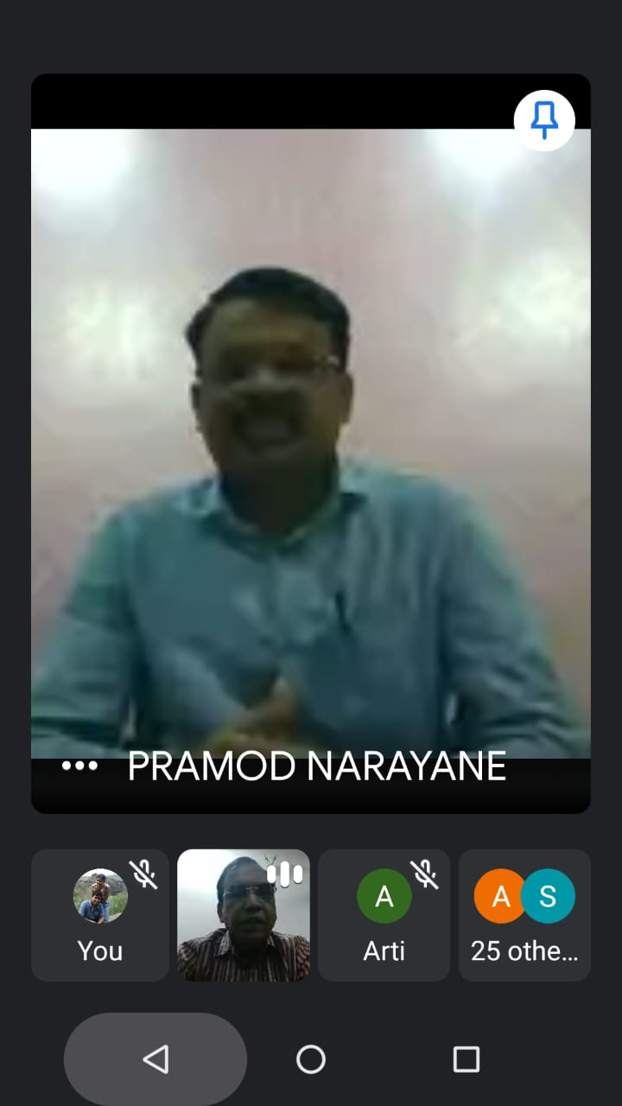
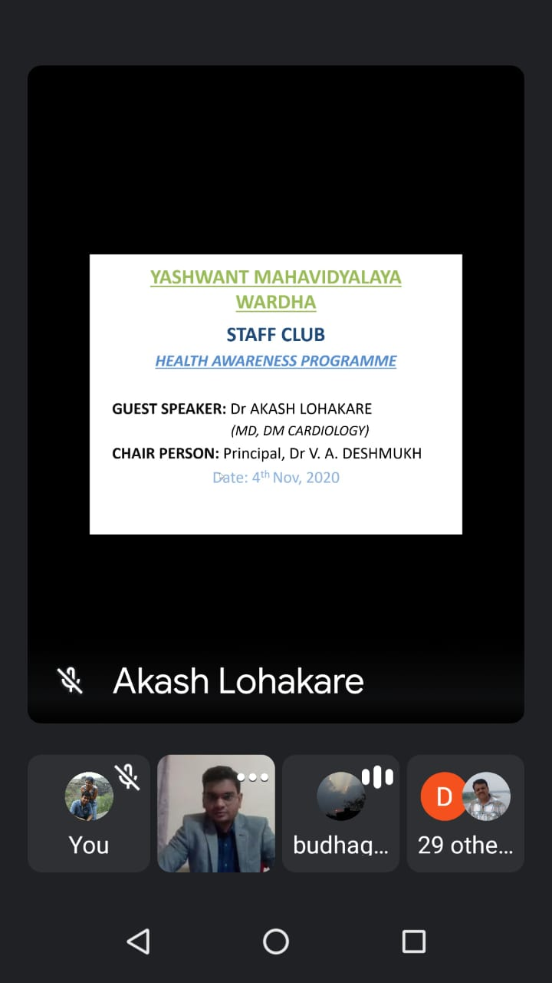
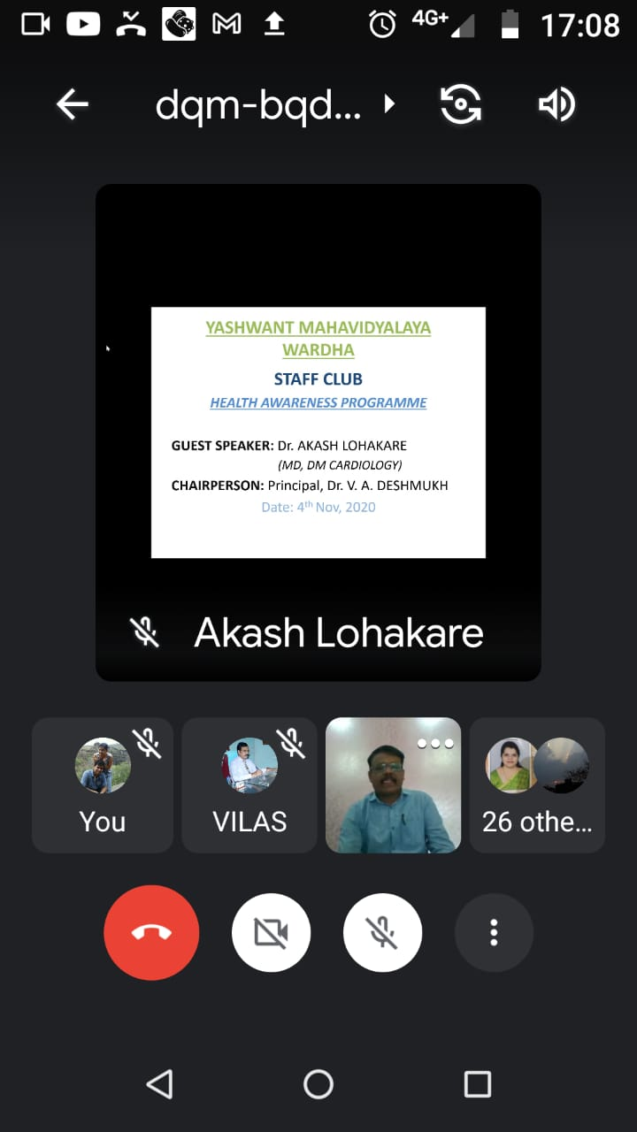
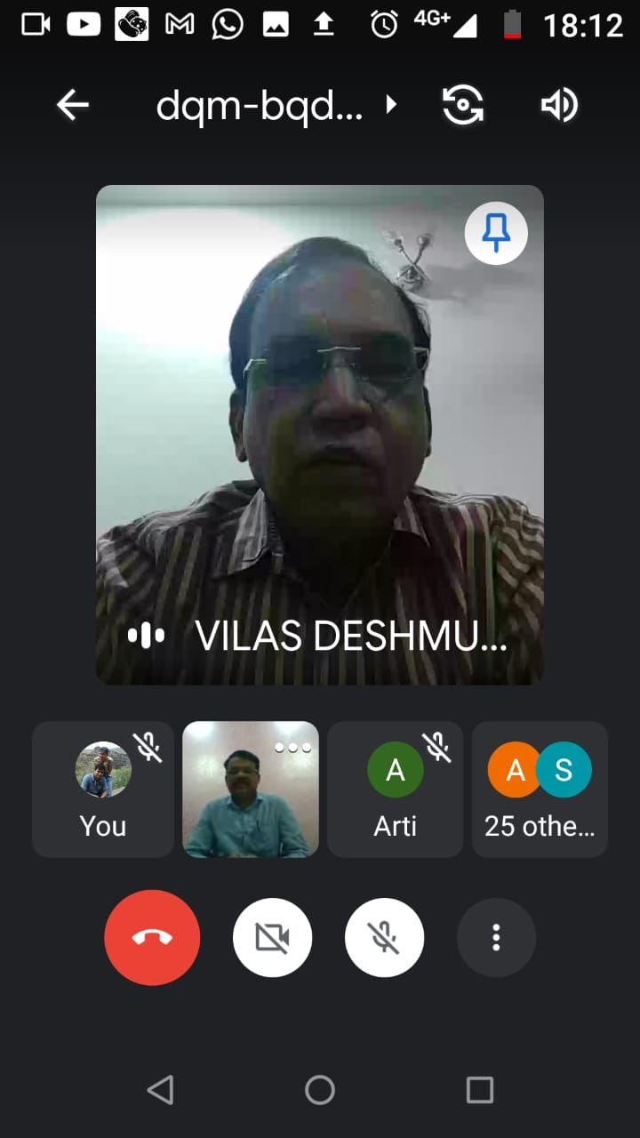
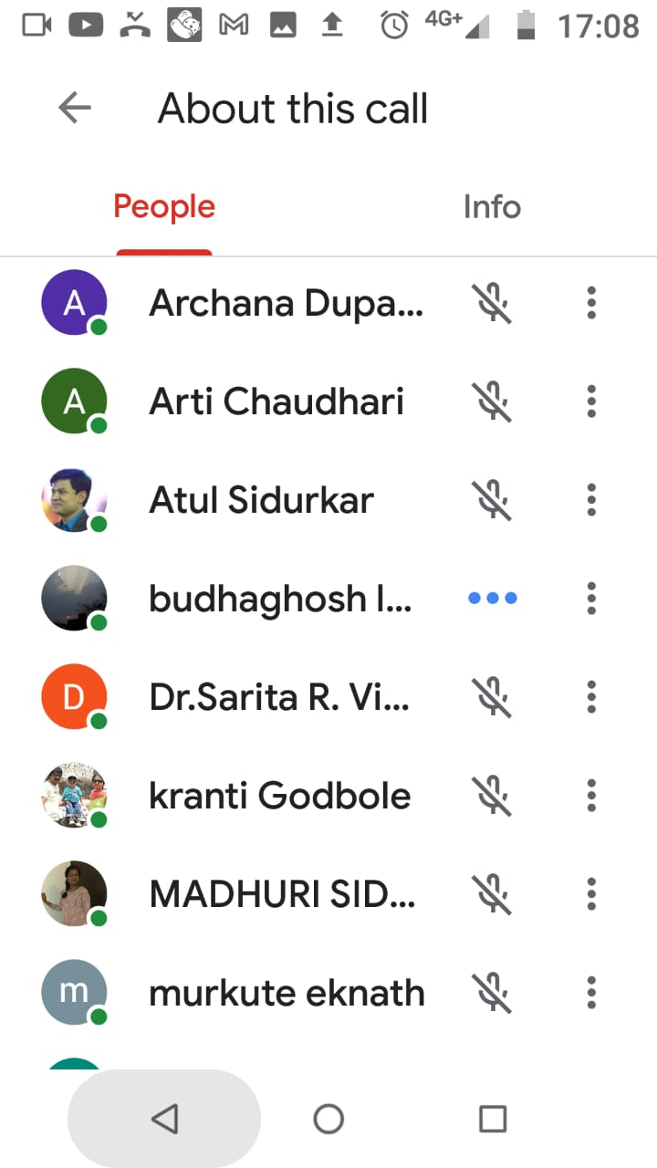
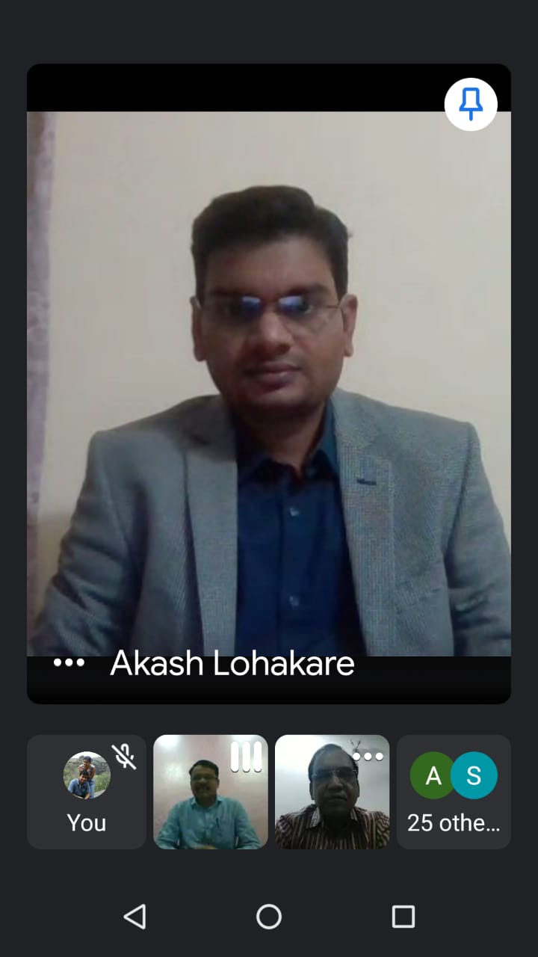
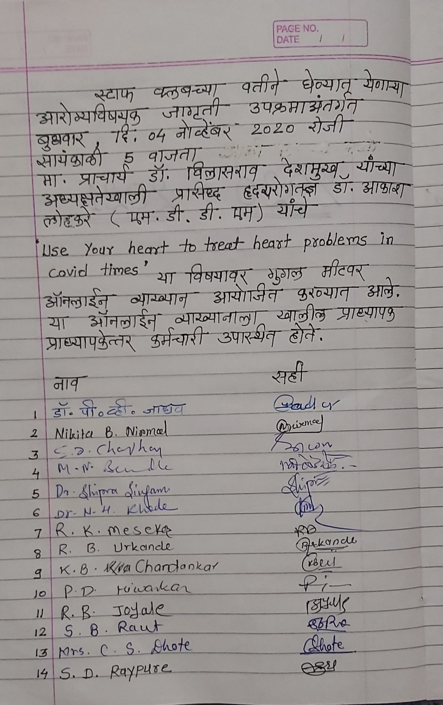
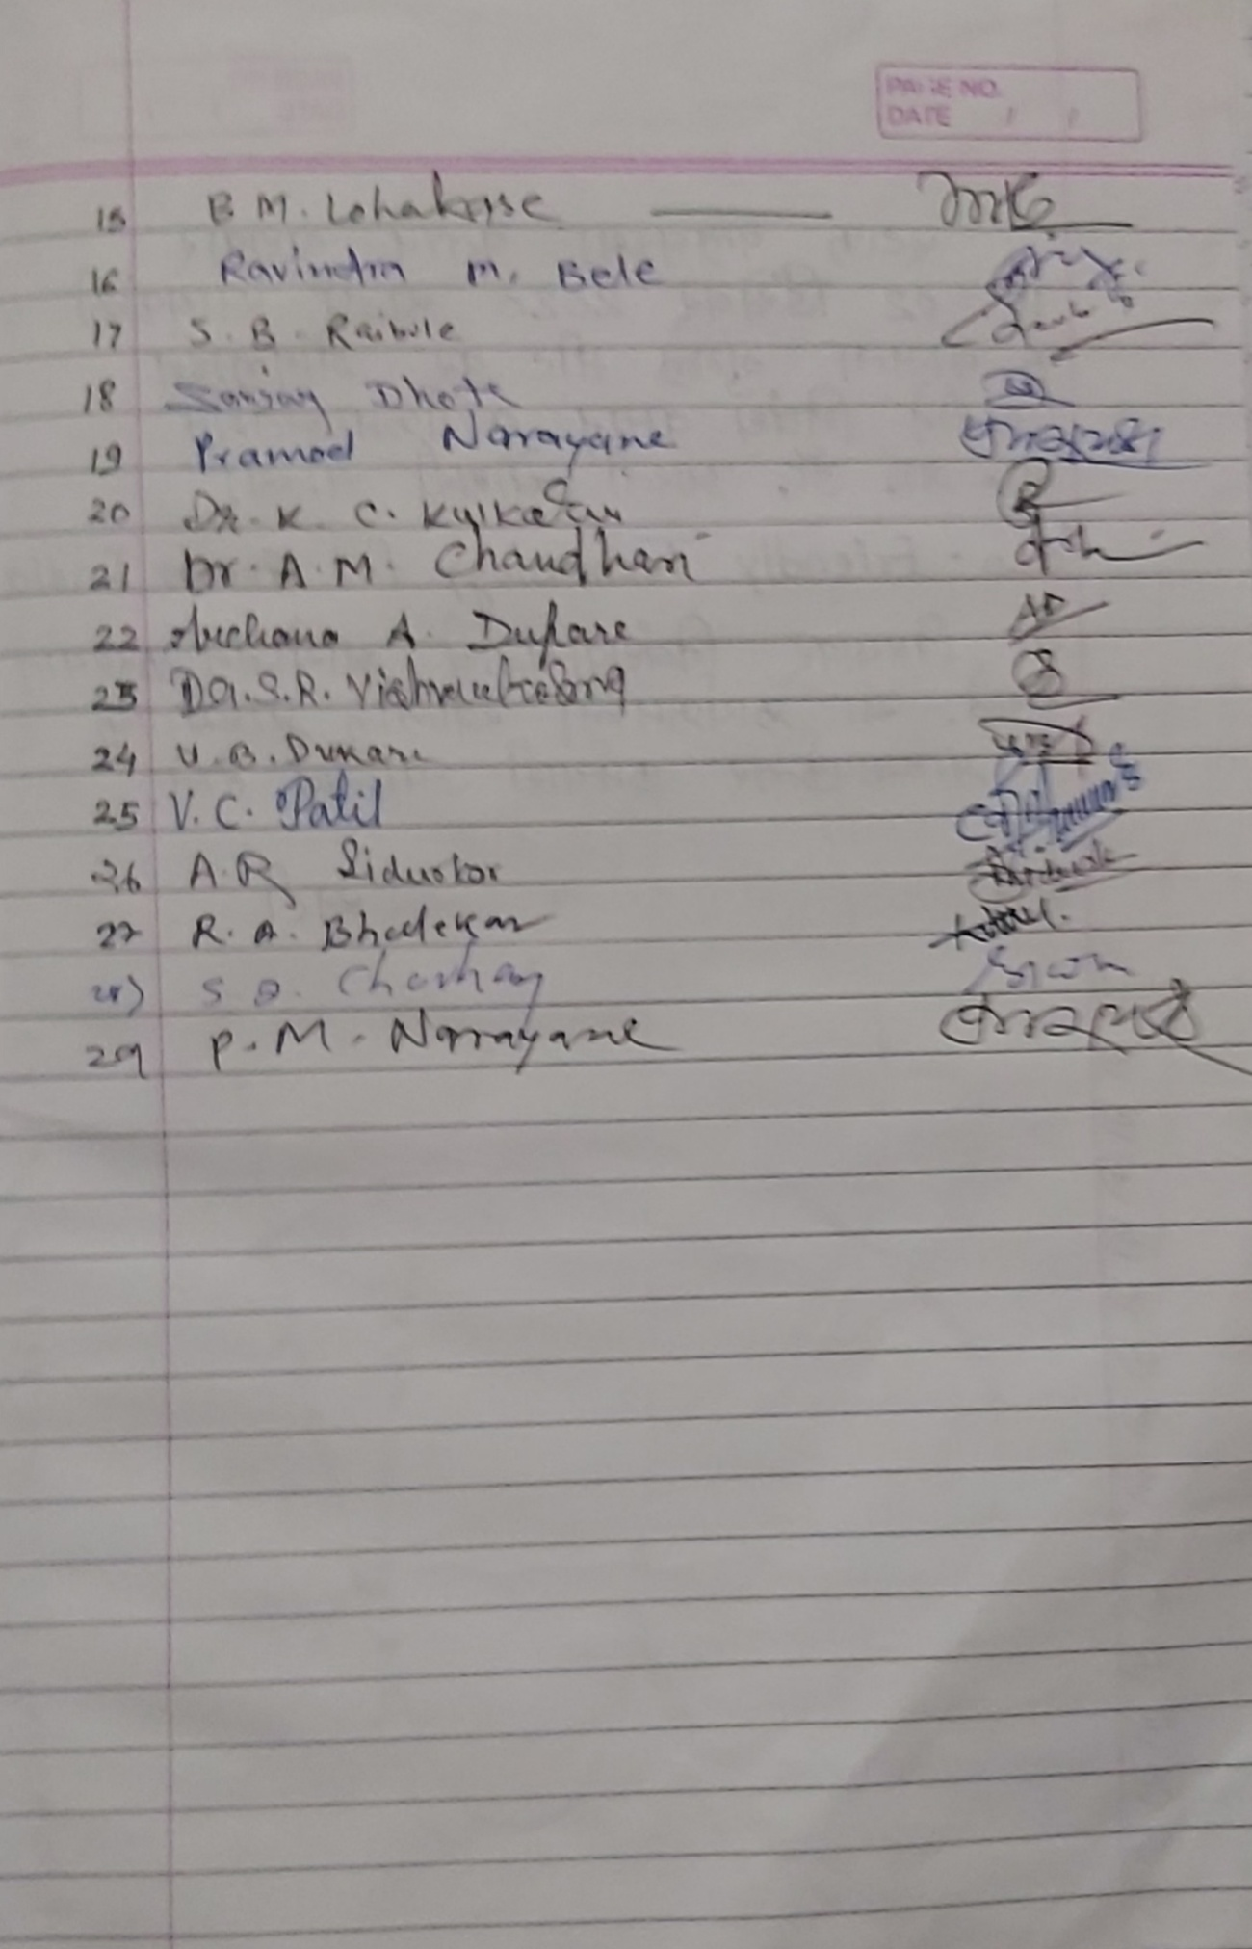

Yeshwant Mahavidyalaya, Wardha
Staff Club
Activity Organised Report
Session 2020-2021

Name of the activity organized | Paper reading
Title of the Paper | Eco- Friendly Technology for Green India
Name of the paper reader | Dr. Aarati Choudhari
Date of activity organized | 02.12. 2020
Name of the chairperson | Principal Dr. V. A. Deshmukh
Place of the activity | Online
Name of the co-ordinator activity | Prof. Pramod Narayane
Objective of the Activity | To provide every person with opportunities to acquire knowledge, values attitudes commitment and skills needed to protect and improve the environment.  To create awareness among society to acquire knowledge of Environmental pollution and degradation.  Introduces nanomaterials for societal benefits and contribution in making GREEN INDIA
Outcome of the activity | Motivating public to participate in environment protection and environment improvement.  It will crete new patterns of behavior of individuals, groups and society as a whole towards environmental protection.  Promotes for sustainable development at personal and Society level.
No. of participation (Staff) | 14
Photo and News | Attached
Signature sheet of Staff and Students | Attached

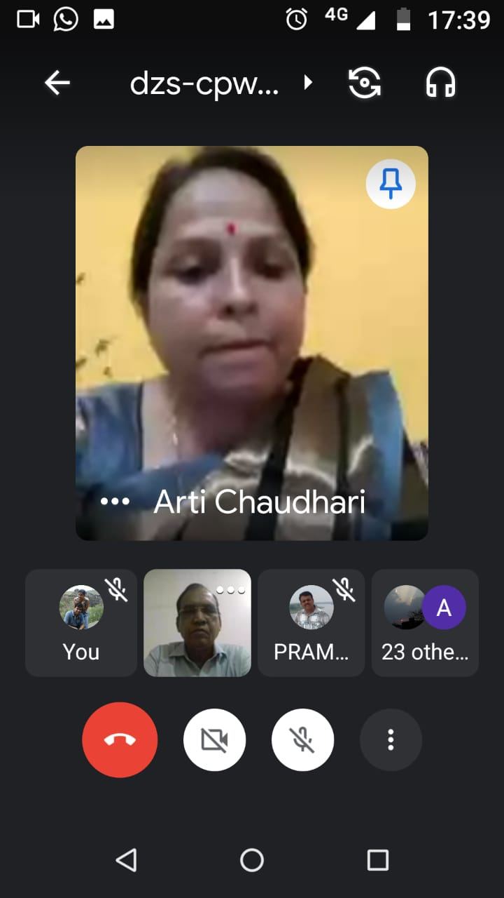
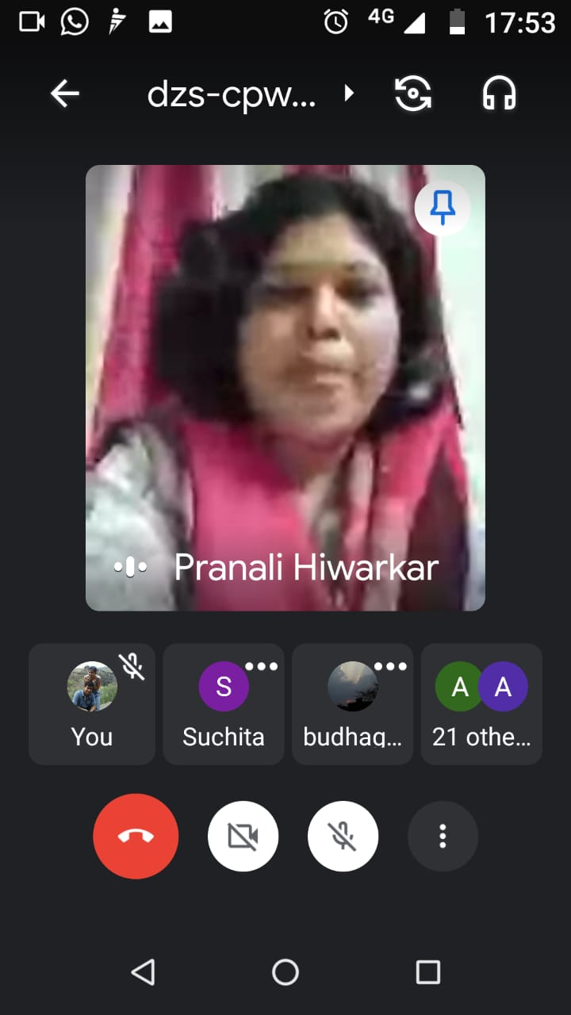
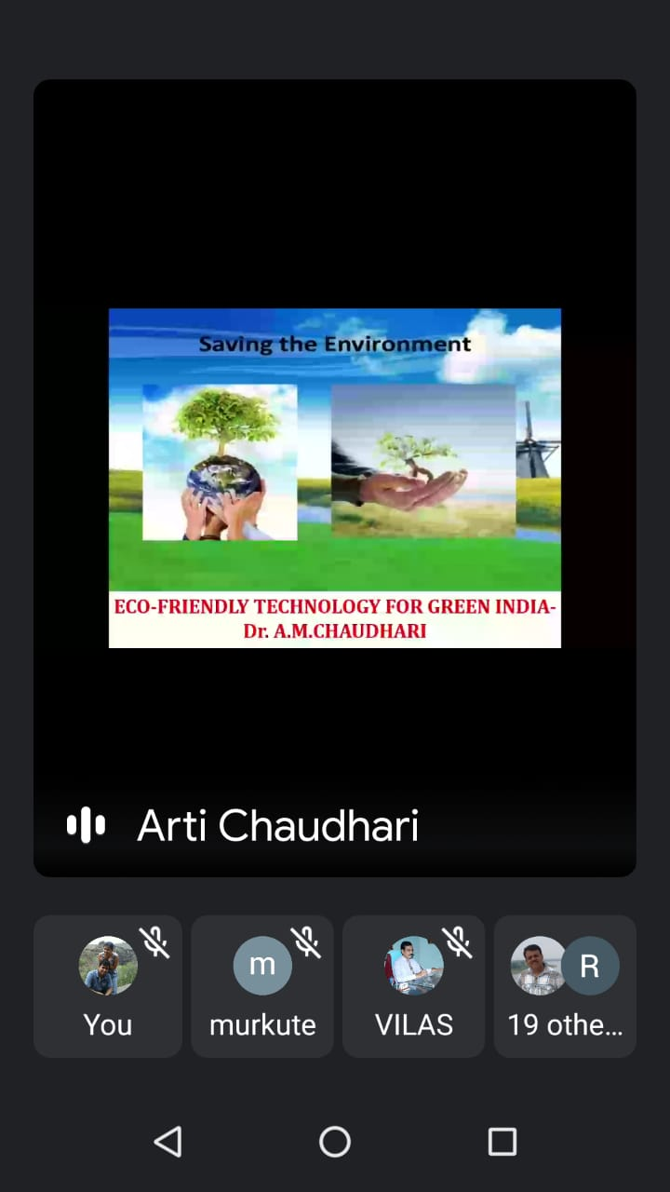
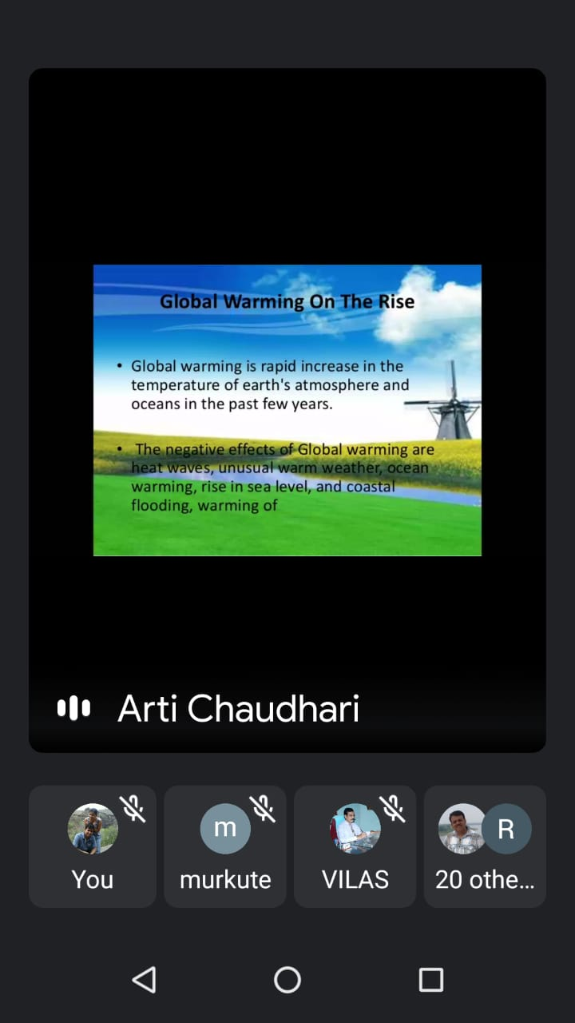
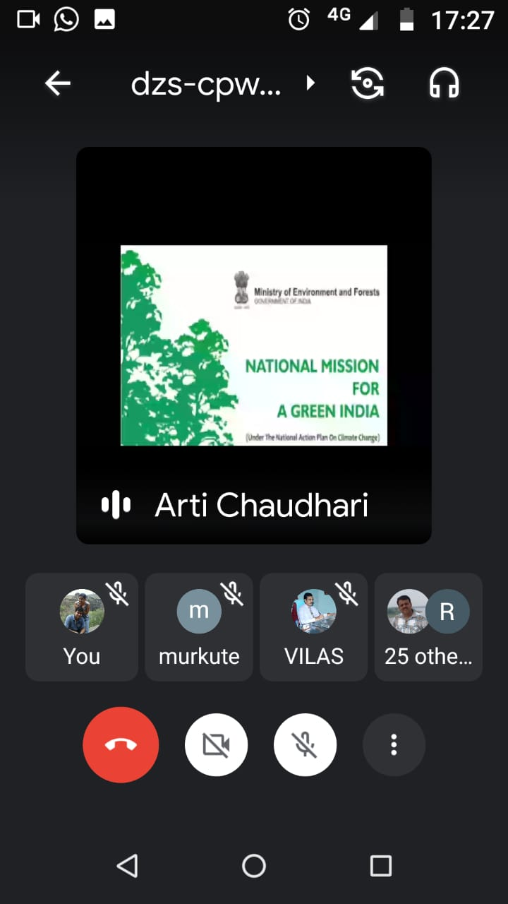
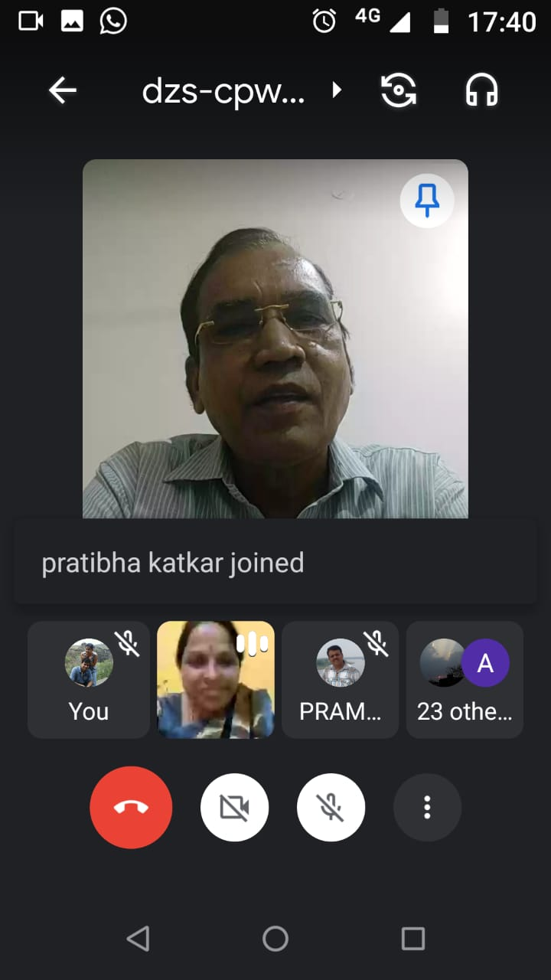
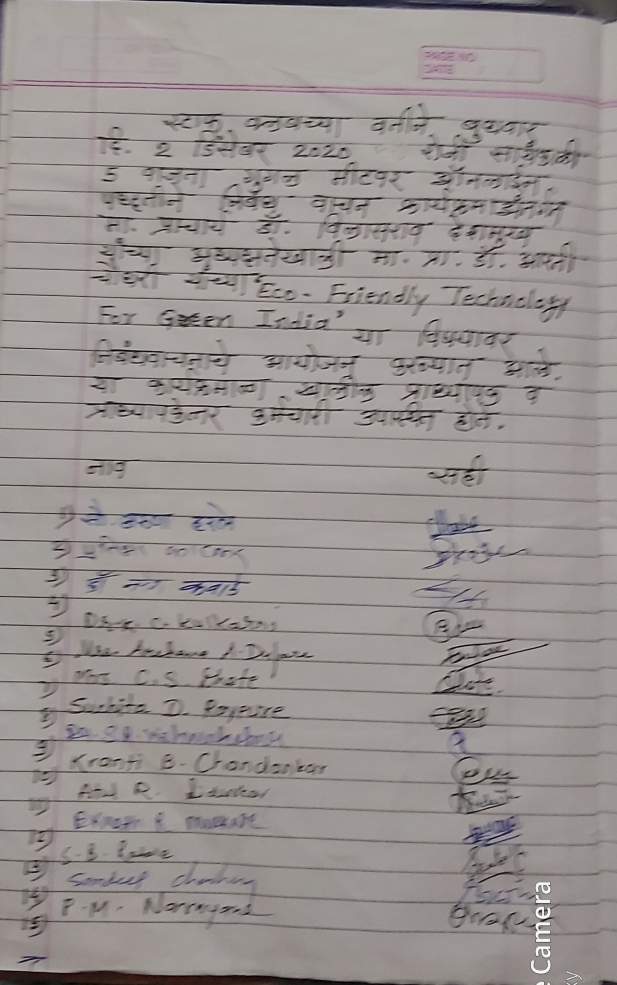

Yeshwant Mahavidyalaya, Wardha
Staff Club
Activity Organised Report
Session 2020-2021

Name of the activity organized | Paper reading
Title of the Paper | Koronakal and Sharirik Swasthya
Name of the paper reader | Kiran Kale
Date of activity organized | 16. 12. 2020
Name of the chairperson | Dr. Aarati Choudhari
Place of the activity | Room No. 8
Name of the co-ordinator activity | Prof. Pramod Narayane
Objective of the Activity | To create awareness about Physical and Mental Health  To aware how to prevent our health and social health.During Pendamic period  To provide information about the fitness during pendamic
Outcome of the activity | People are also come to know about the importants of Physical and Mental Health  People are also come to know about the importants of social Health  Created Health awareness in Society
No. of participation (Staff) | 26
Photo and News | Attached
Signature sheet of Staff and Students | Attached

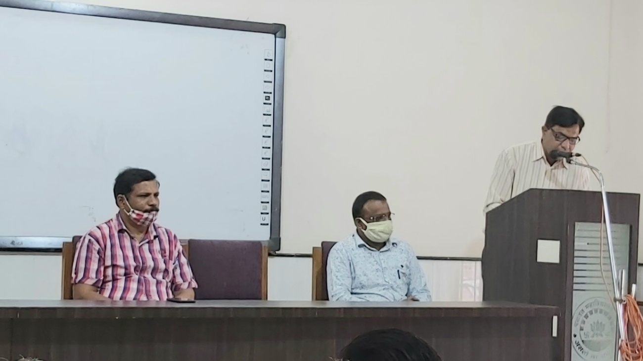

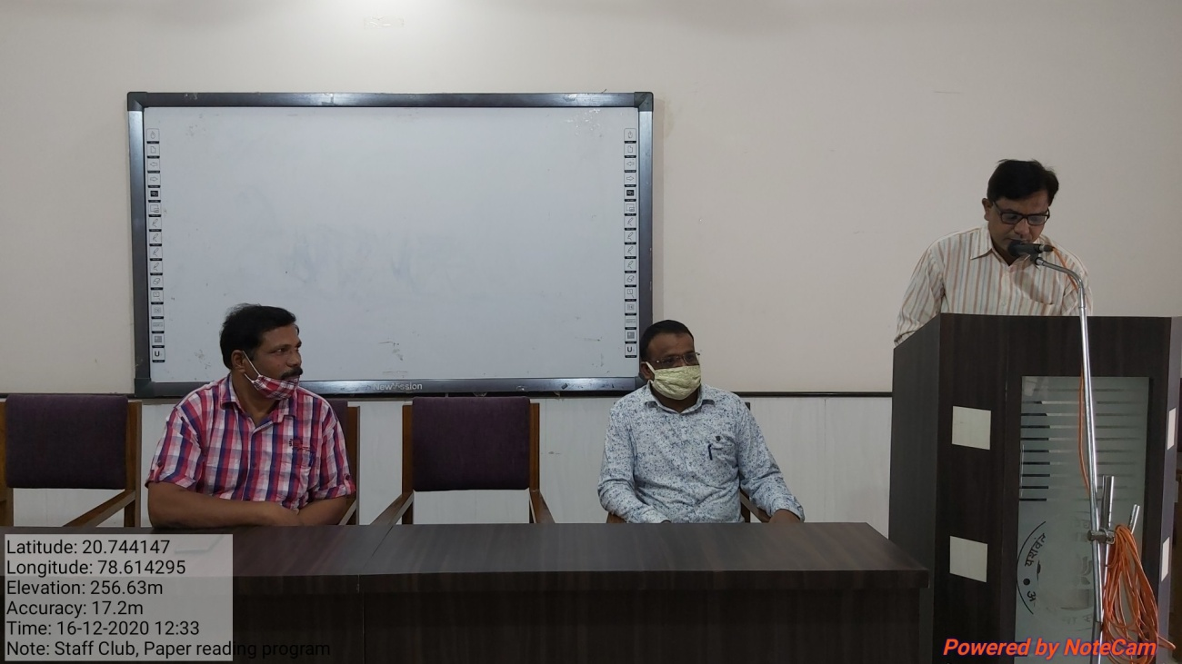

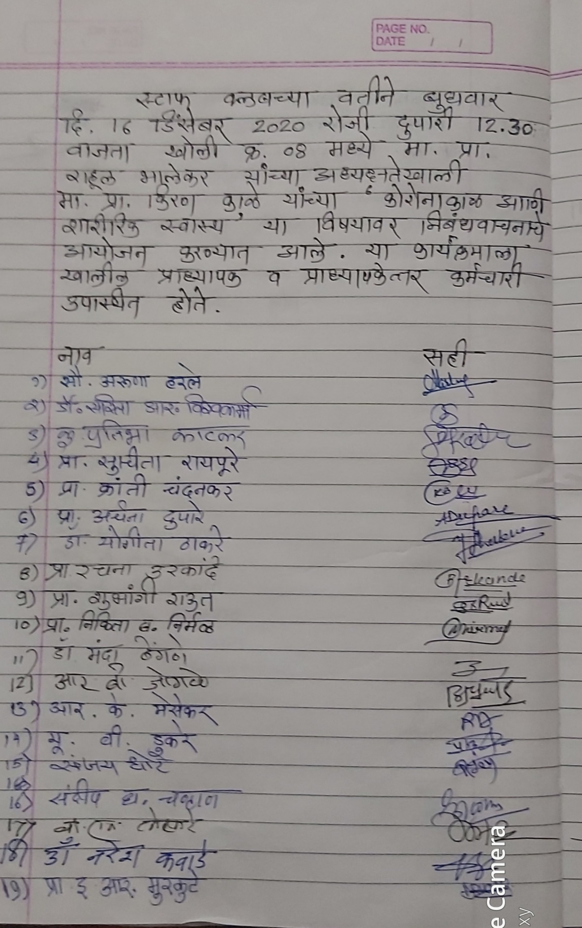
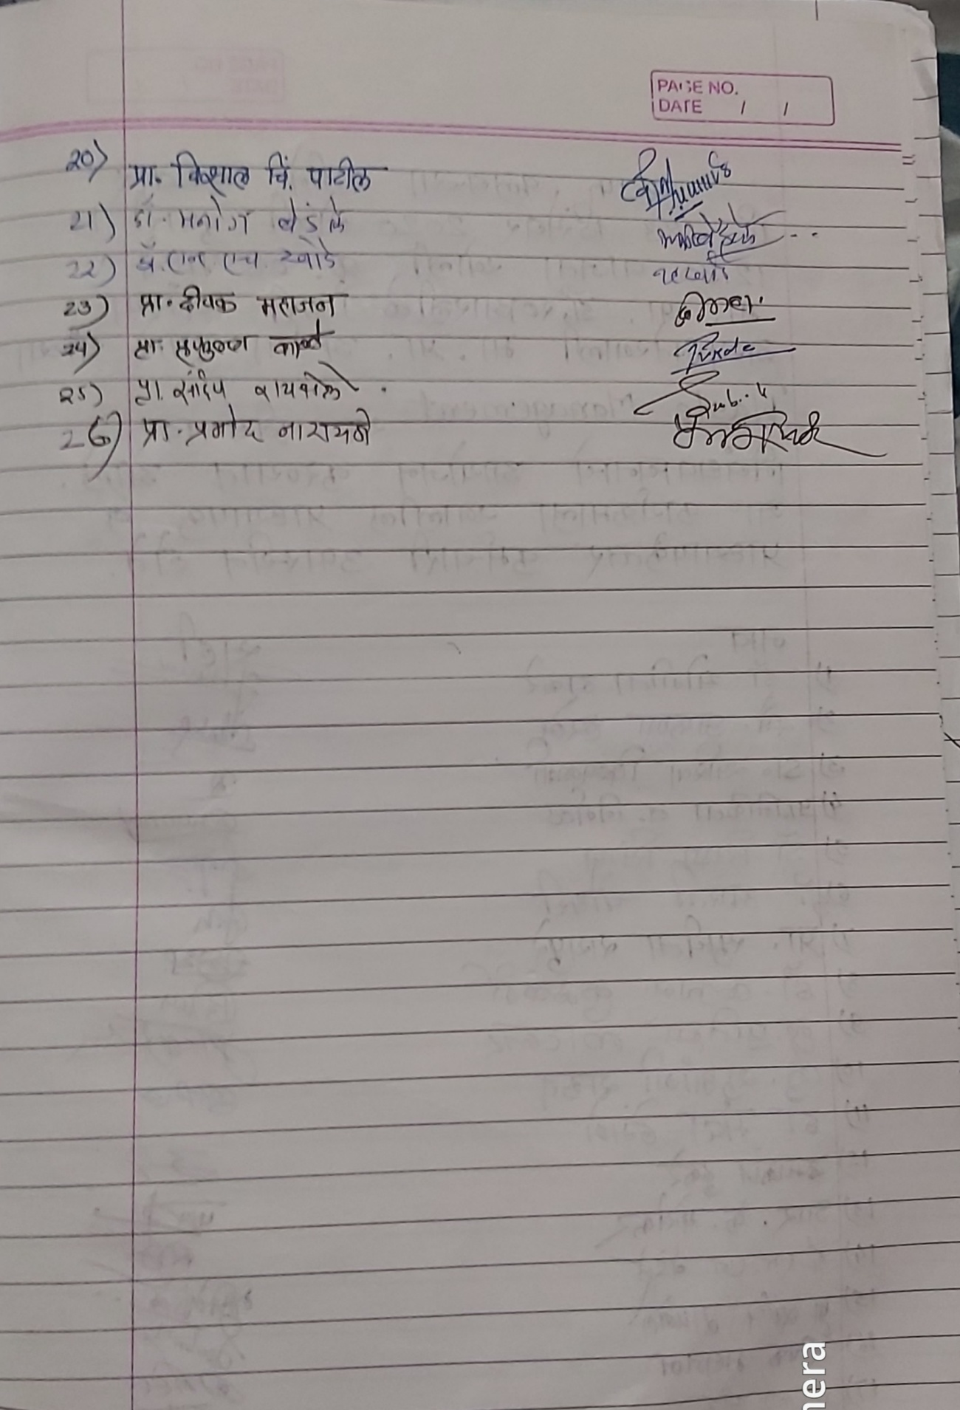

Yeshwant Mahavidyalaya, Wardha
Staff Club
Activity Organised Report
Session 2020-21
3
Name of the activity organized | Paper reading
Title of the Paper | Waste Management
Name of the paper reader | Archana Dupare
Date of activity organized | 23. 12. 2020
Name of the chairperson | Kiran Kale
Place of the activity | Room No. 8
Name of the co-ordinator activity | Prof. Pramod Narayane
Objective of the Activity | To study different types of waste  Utilizing kitchen waste for preparation of compost  To save Environment from pollution.
Outcome of the activity | Utilization of resources  Save environment  Save Money  It is socially and economically beneficial to society
No. of participation (Staff) | 27
Photo and News | Attached
Signature sheet of Staff | Attached

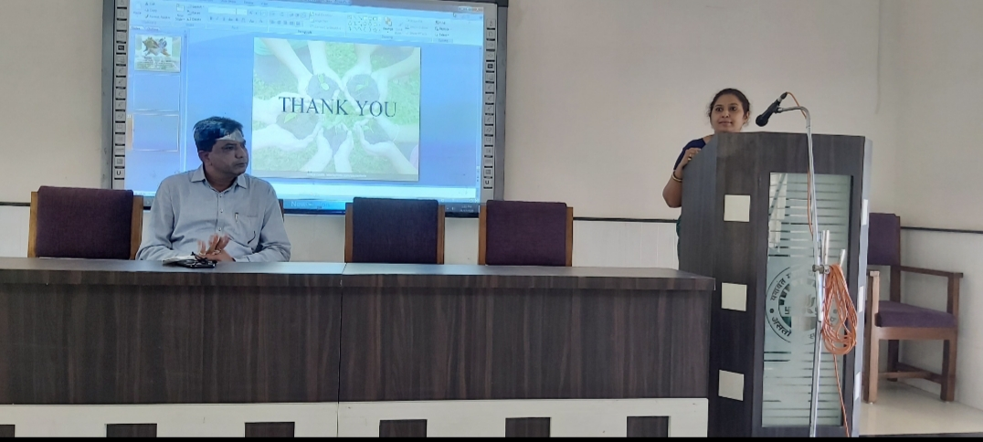
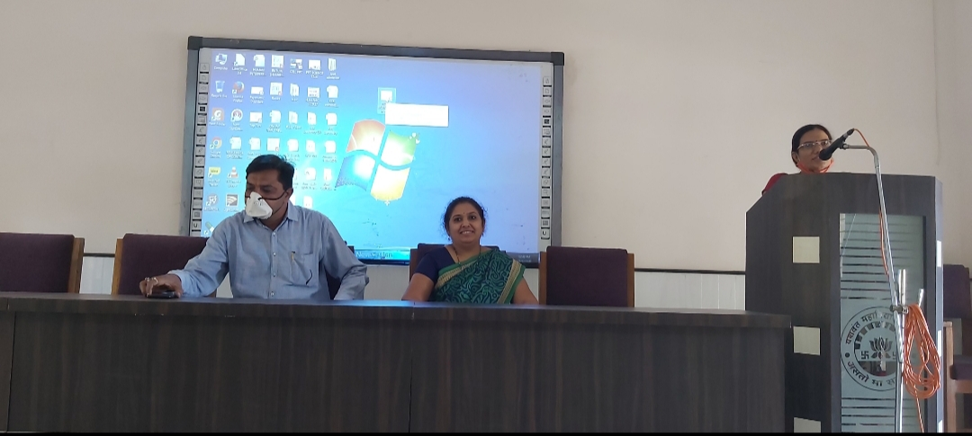
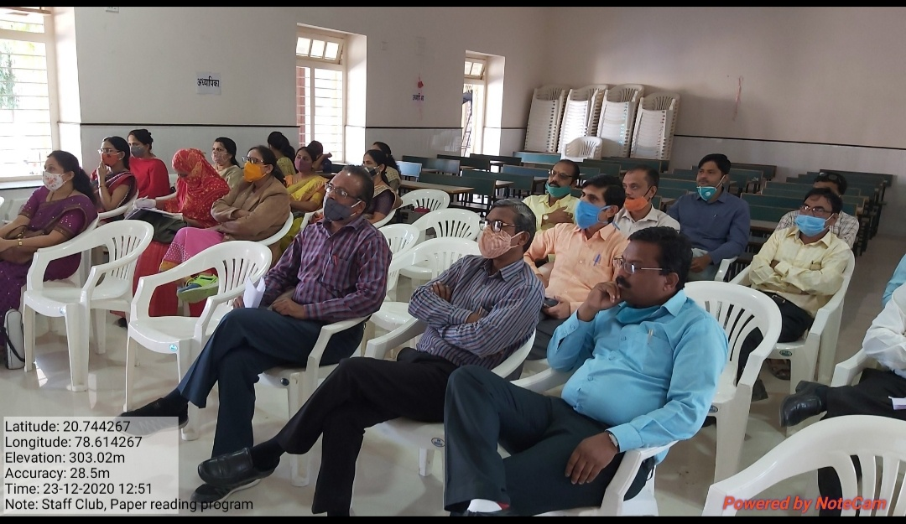

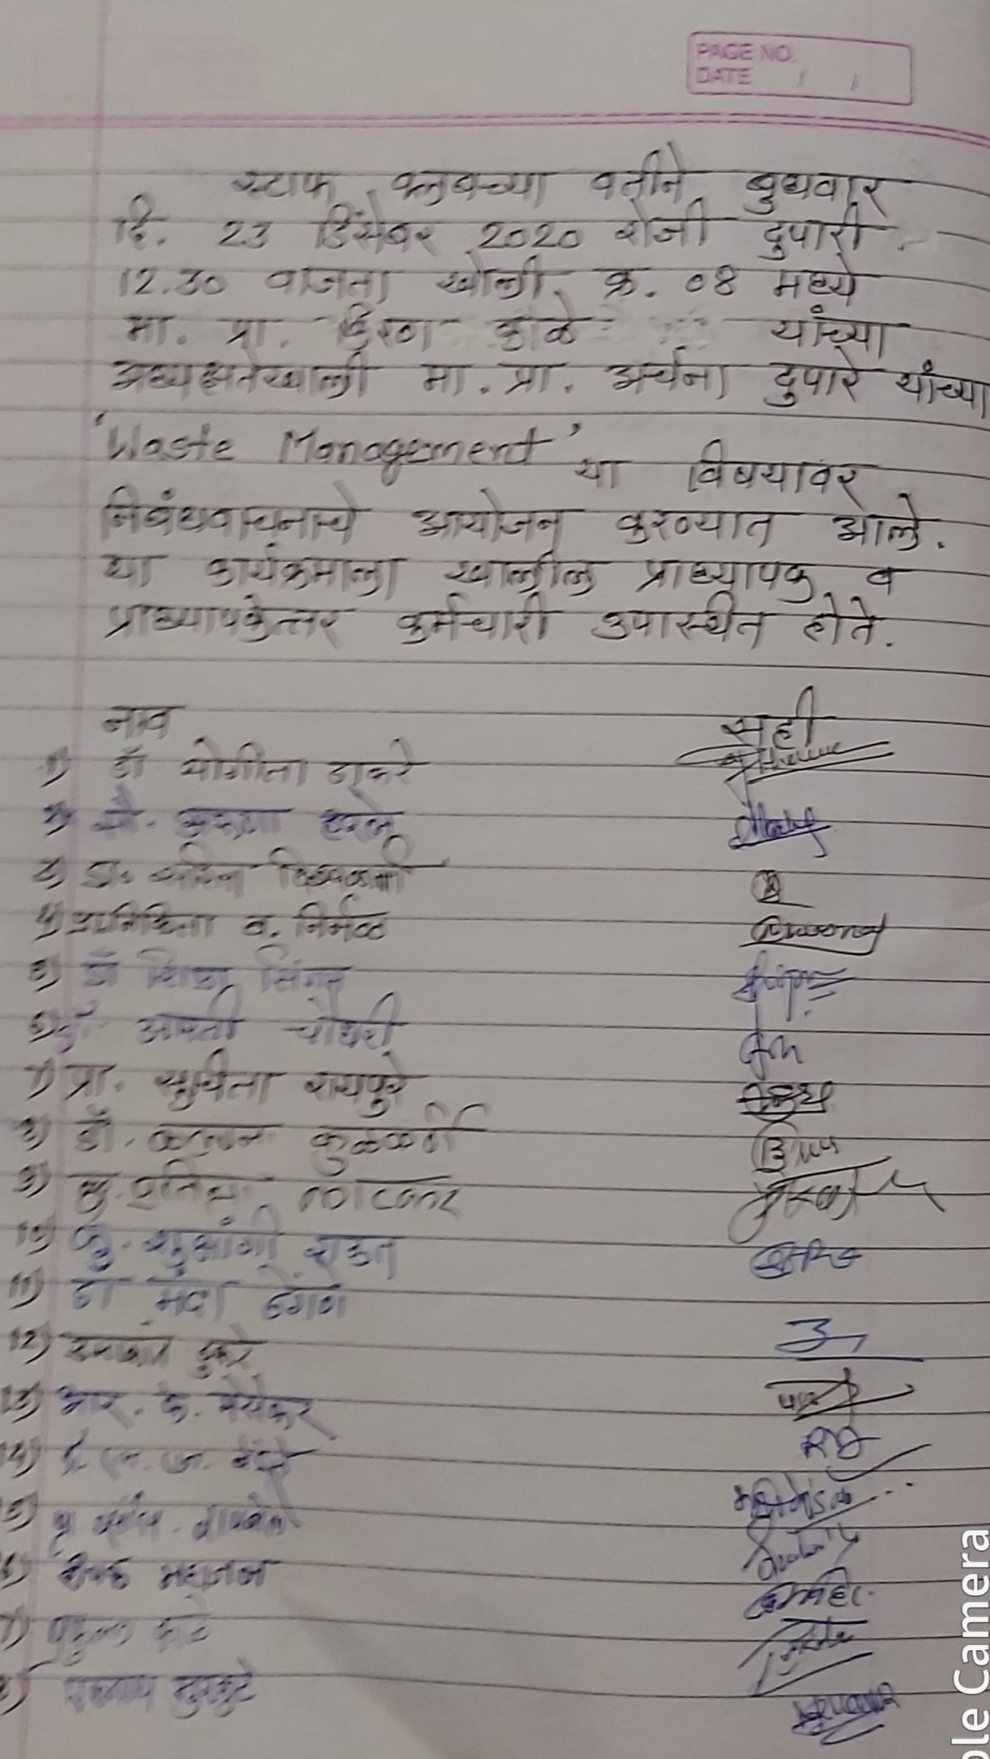
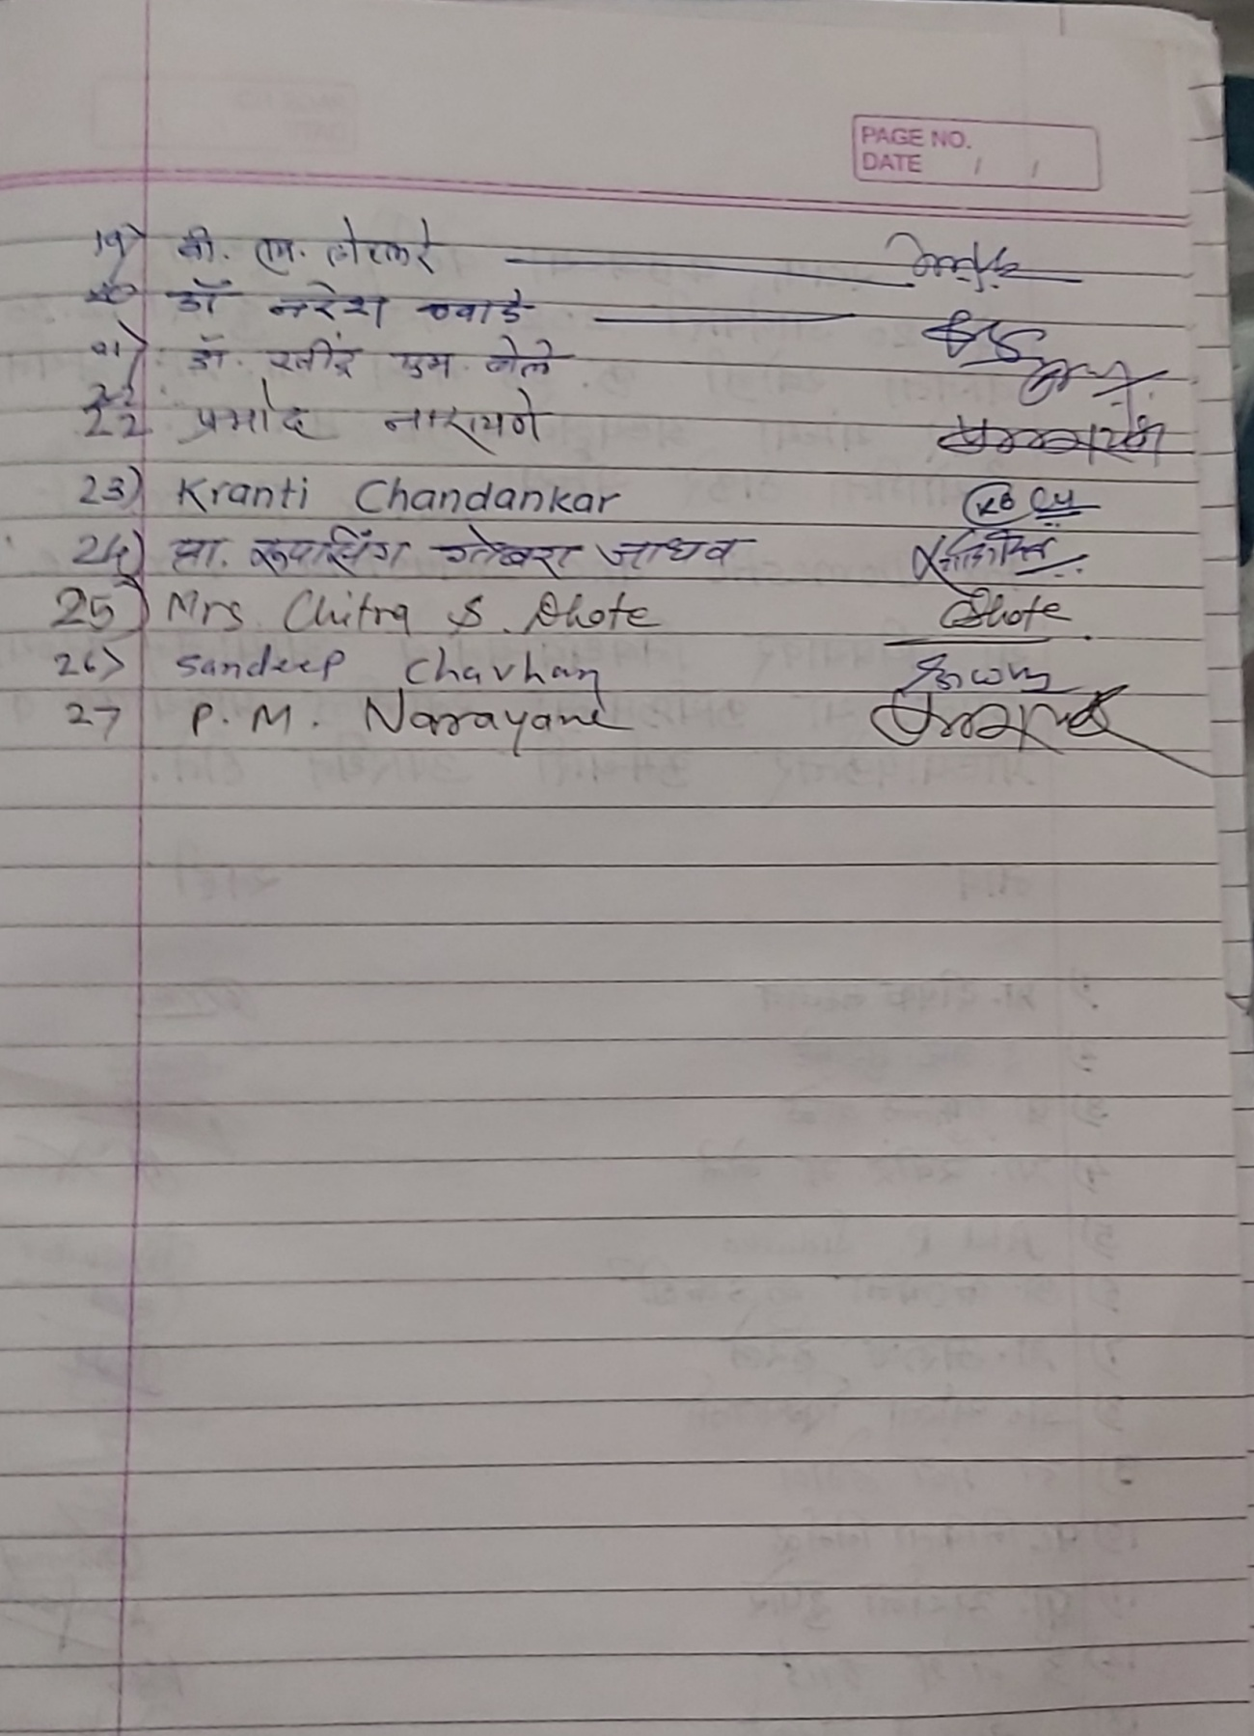

Yeshwant Mahavidyalaya, Wardha
Staff Club
Activity Organised Report
Session 2020-21

Name of the activity organized | Paper reading
Title of the Paper | Water Treatment For Domestic and Industrial Purpose
Name of the paper reader | Dr. Yogita Thakare
Date of activity organized | 20. 01. 2021
Name of the chairperson | Archana Dupare
Place of the activity | Room No. 8
Name of the co-ordinator activity | Prof. Pramod Narayane
Objective of the Activity | To acquire the knowledge about types of impurities in natural water.  To make the water potable and palatable.  To minimize the effects of impurities in natural water.
Outcome of the activity | Acquired knowledge of impurities present in natural water  Water becomes safe for drinking and indusrial purpose
No. of participation (Staff) | 23
Photo and News | Attached
Signature sheet of Staff | Attached
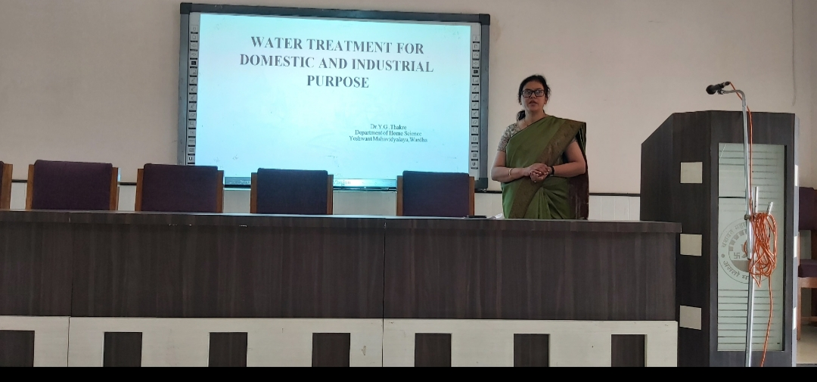
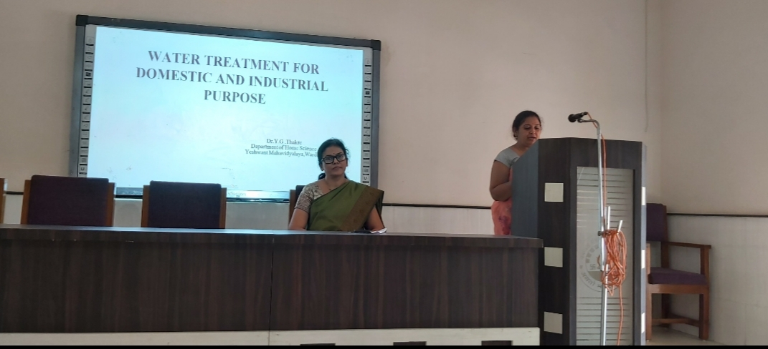

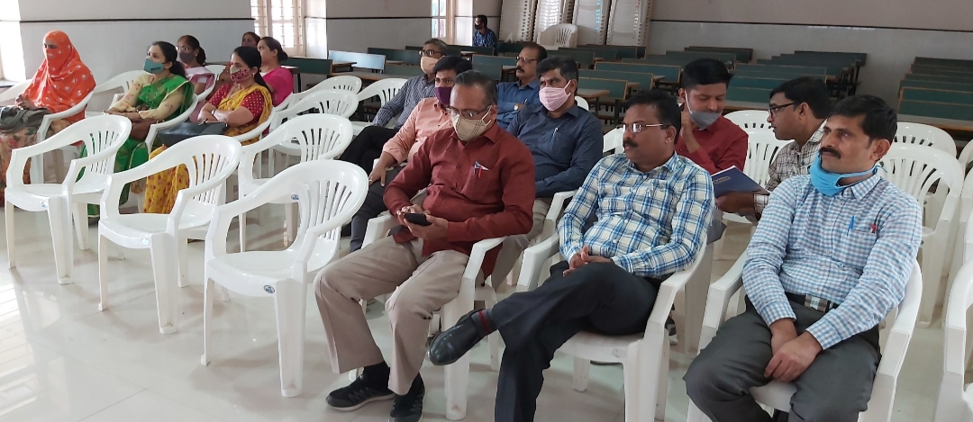
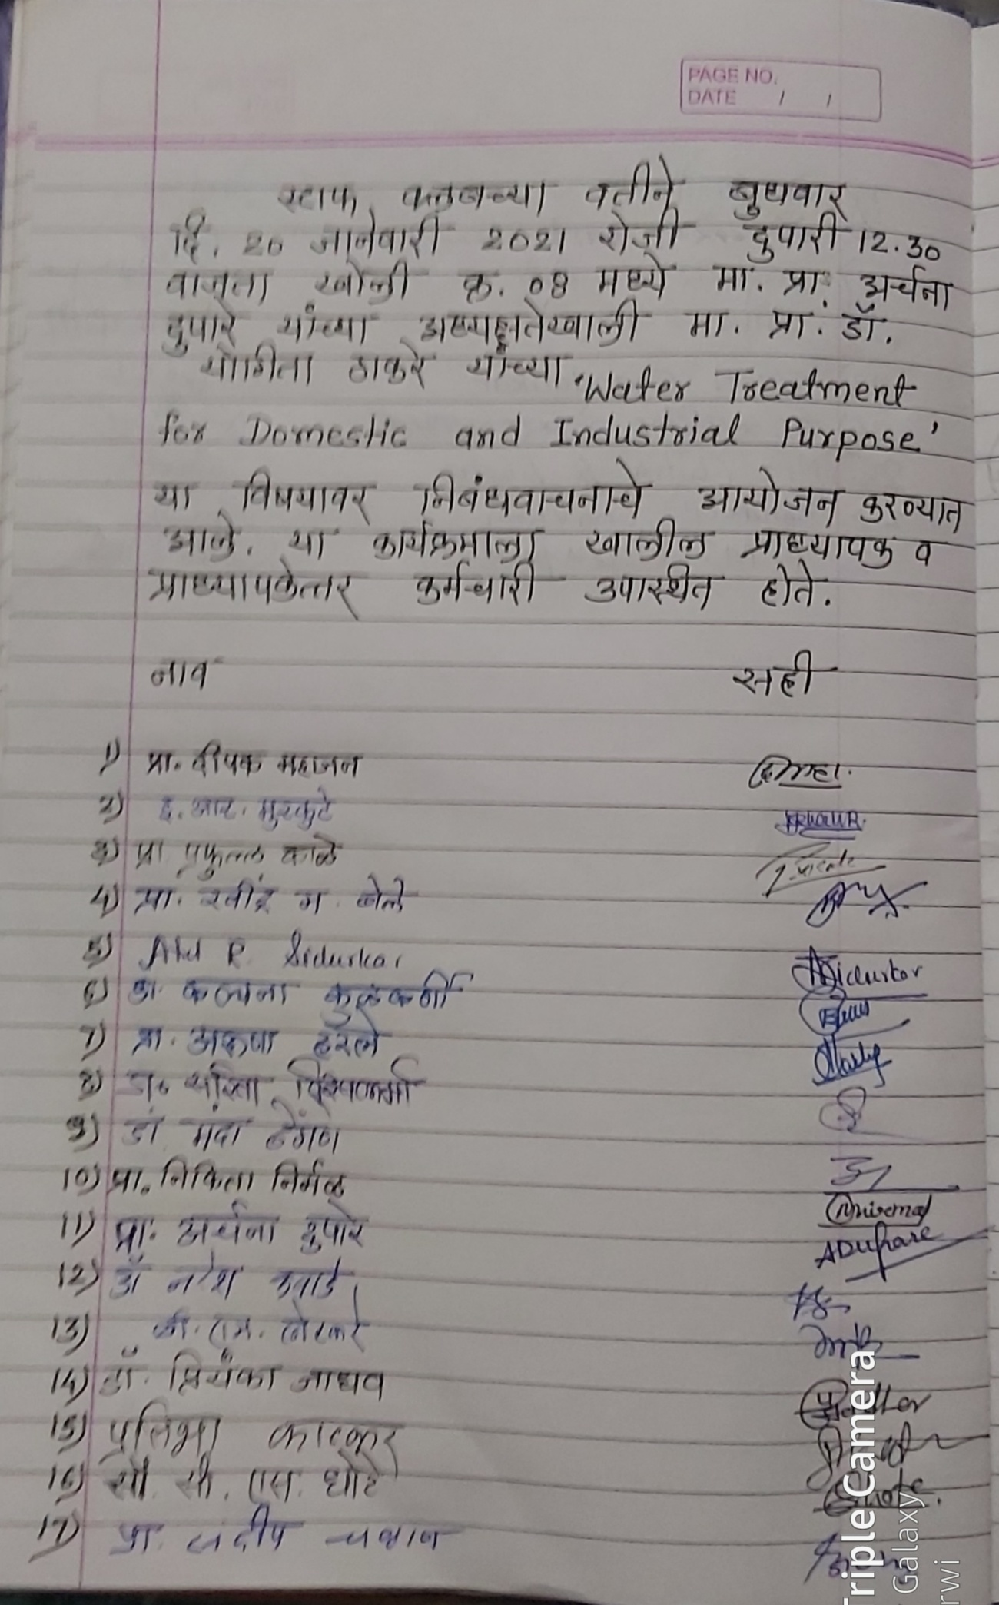
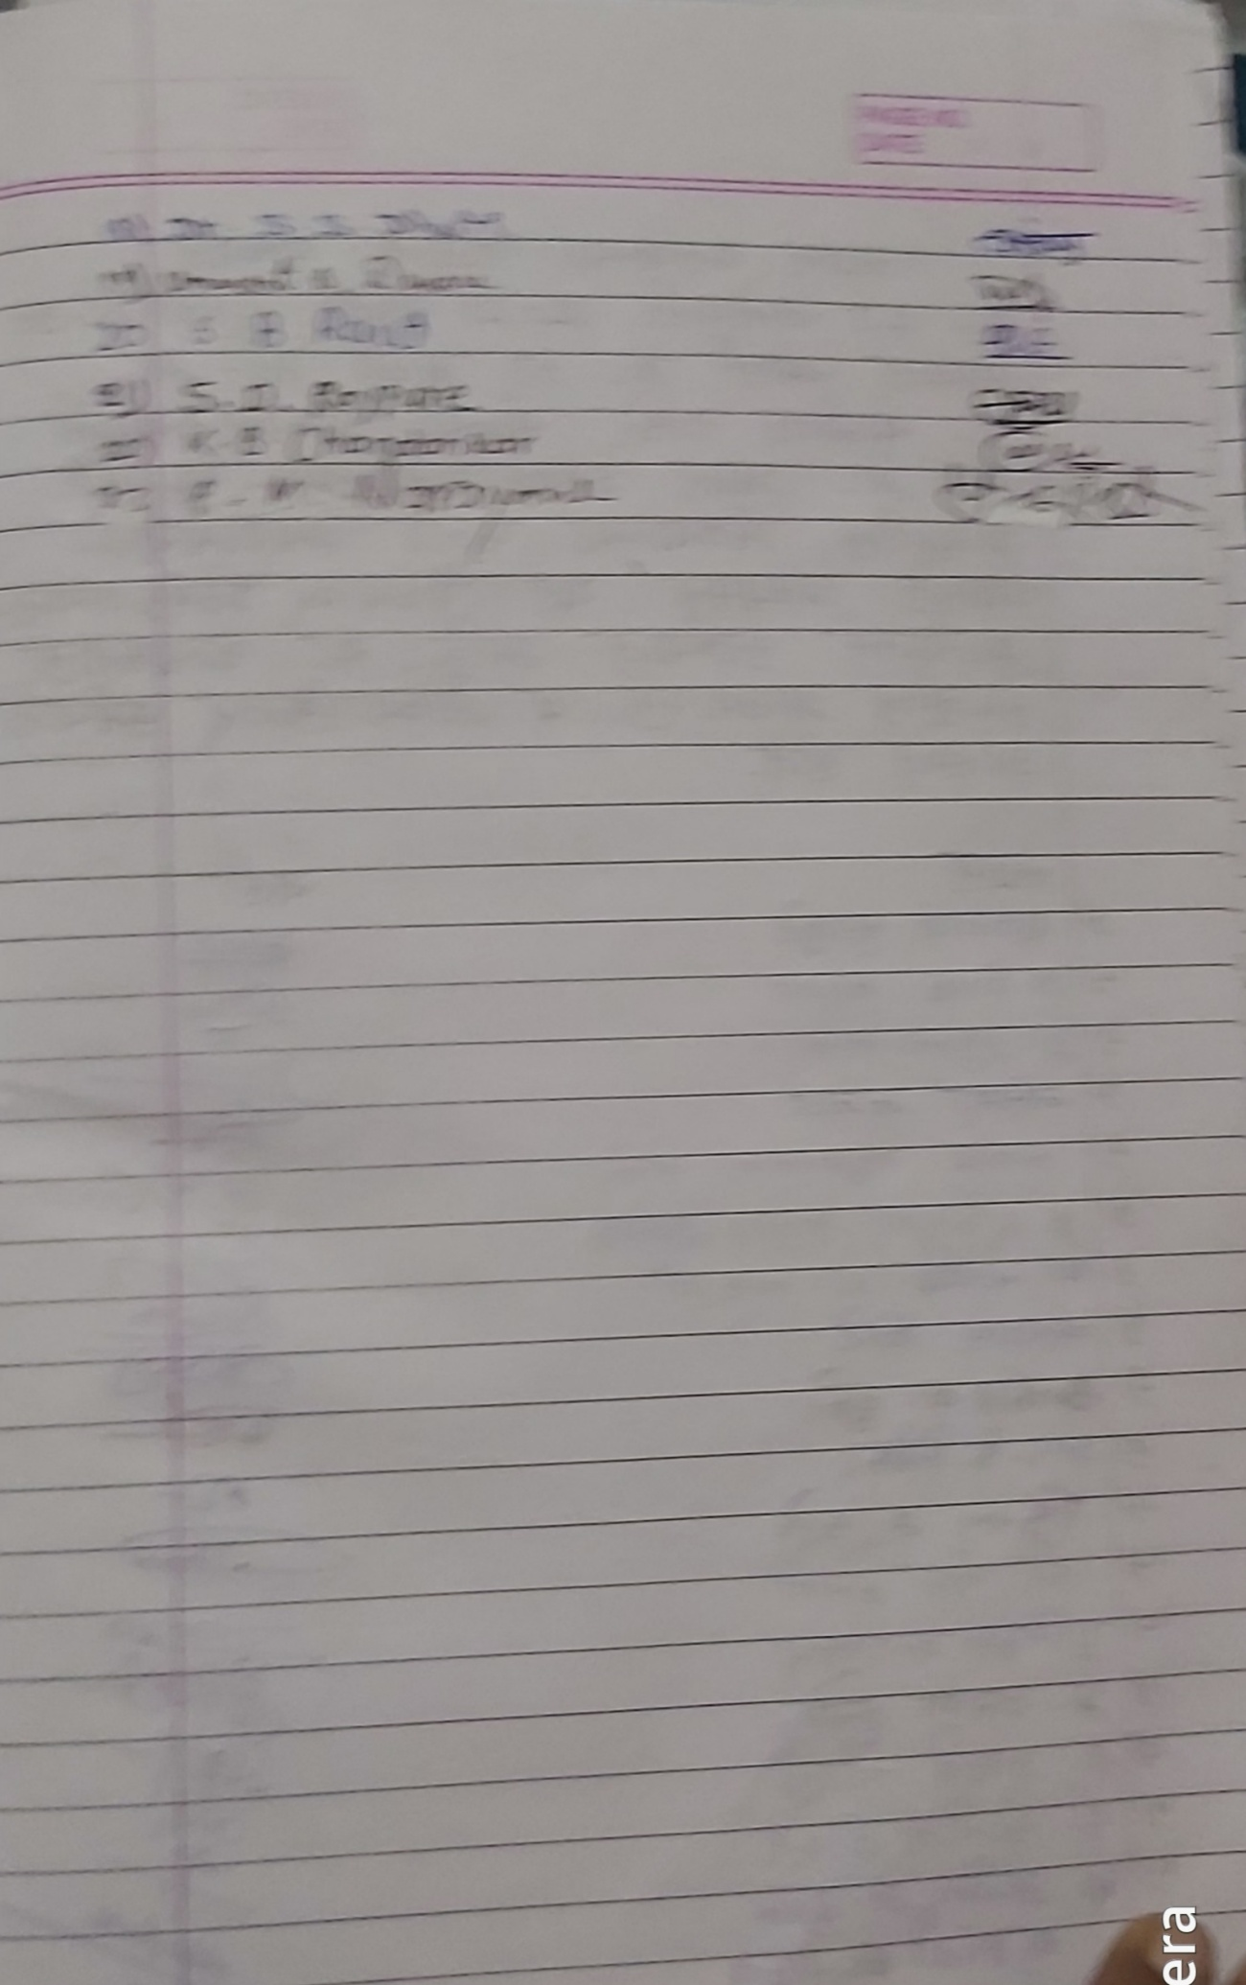

Yeshwant Mahavidyalaya, Wardha
Staff Club
Activity Organised Report
Session 2020-21

Name of the activity organized | Paper reading
Title of the Paper | Gramin Bhagatil Pinyachya Pani Vyavastheche Arthik Adhyayan
Name of the paper reader | Amar Dahane
Date of activity organized | 27. 01. 2021
Name of the chairperson | Yogita Thakare
Place of the activity | Room No. 8
Name of the co-ordinator activity | Prof. Pramod Narayane
Objective of the Activity | To study the effect of the economic and social status of the people of rural areas due to rural deveplopmet plan  To study the participation of rural people for the success of Gram Vikas Yojana  To explore the economic and social contribution in the life of rural people
Outcome of the activity | This scheme has increased employment in rural areas.  Local public participation has increased for success of rural development schemes  The scheme undertaken for the study has helped in raising the standard of living and overall development of the rural people in terma of economic] social and health.
No. of participation (Staff) | 29
Photo and News | Attached
Signature sheet of Staff | Attached

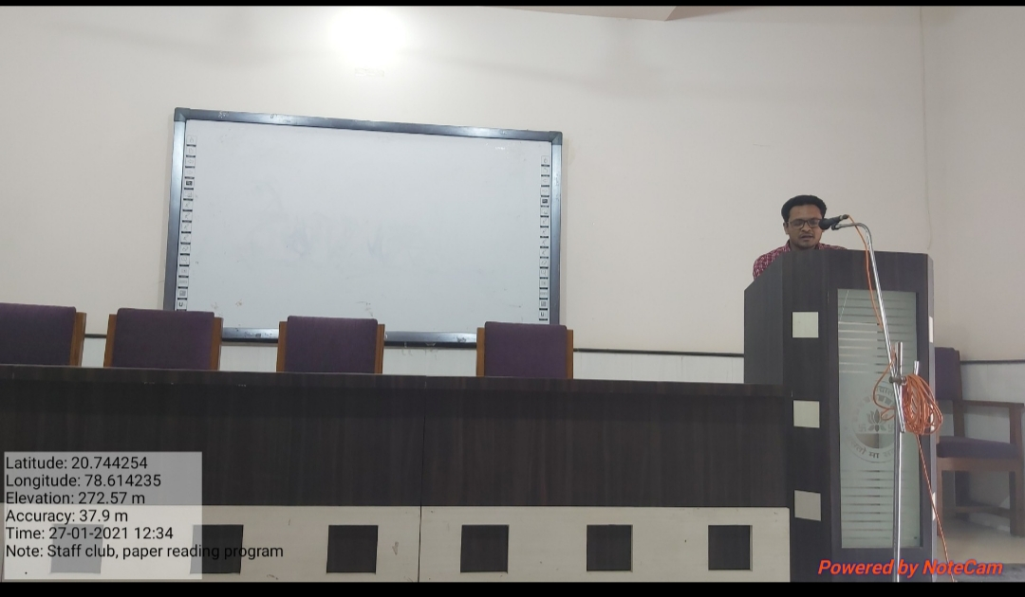
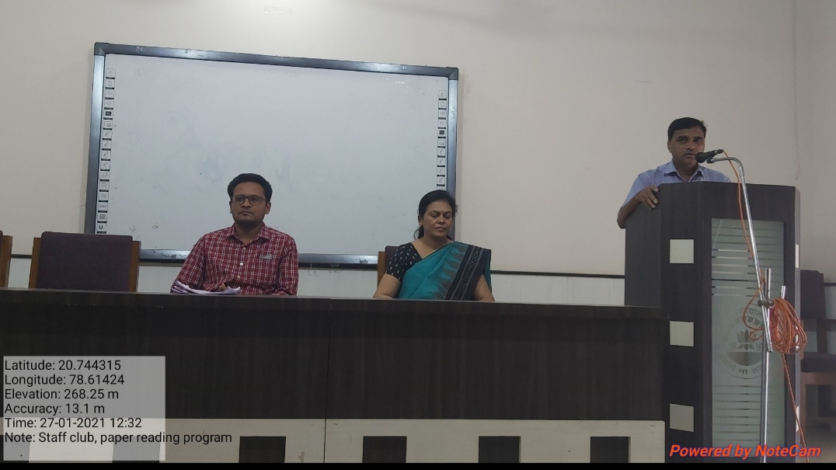
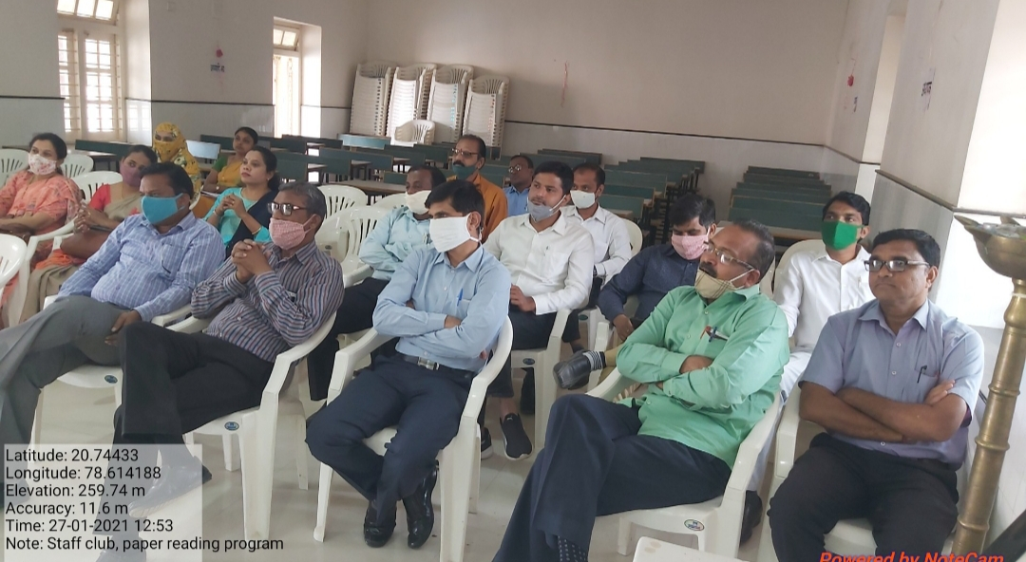
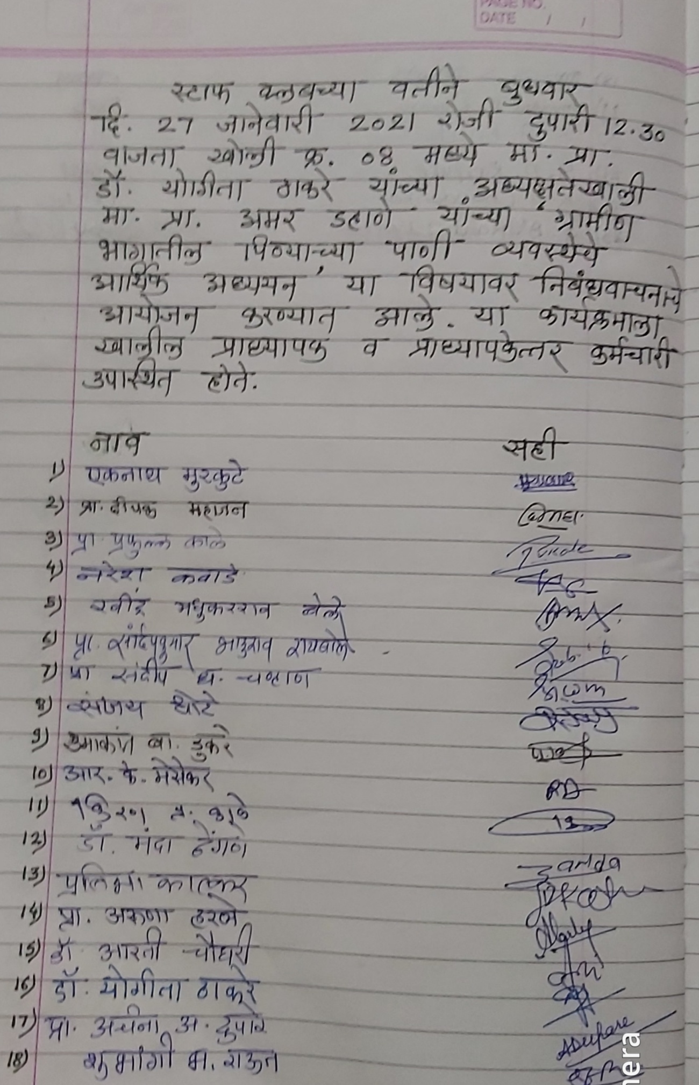
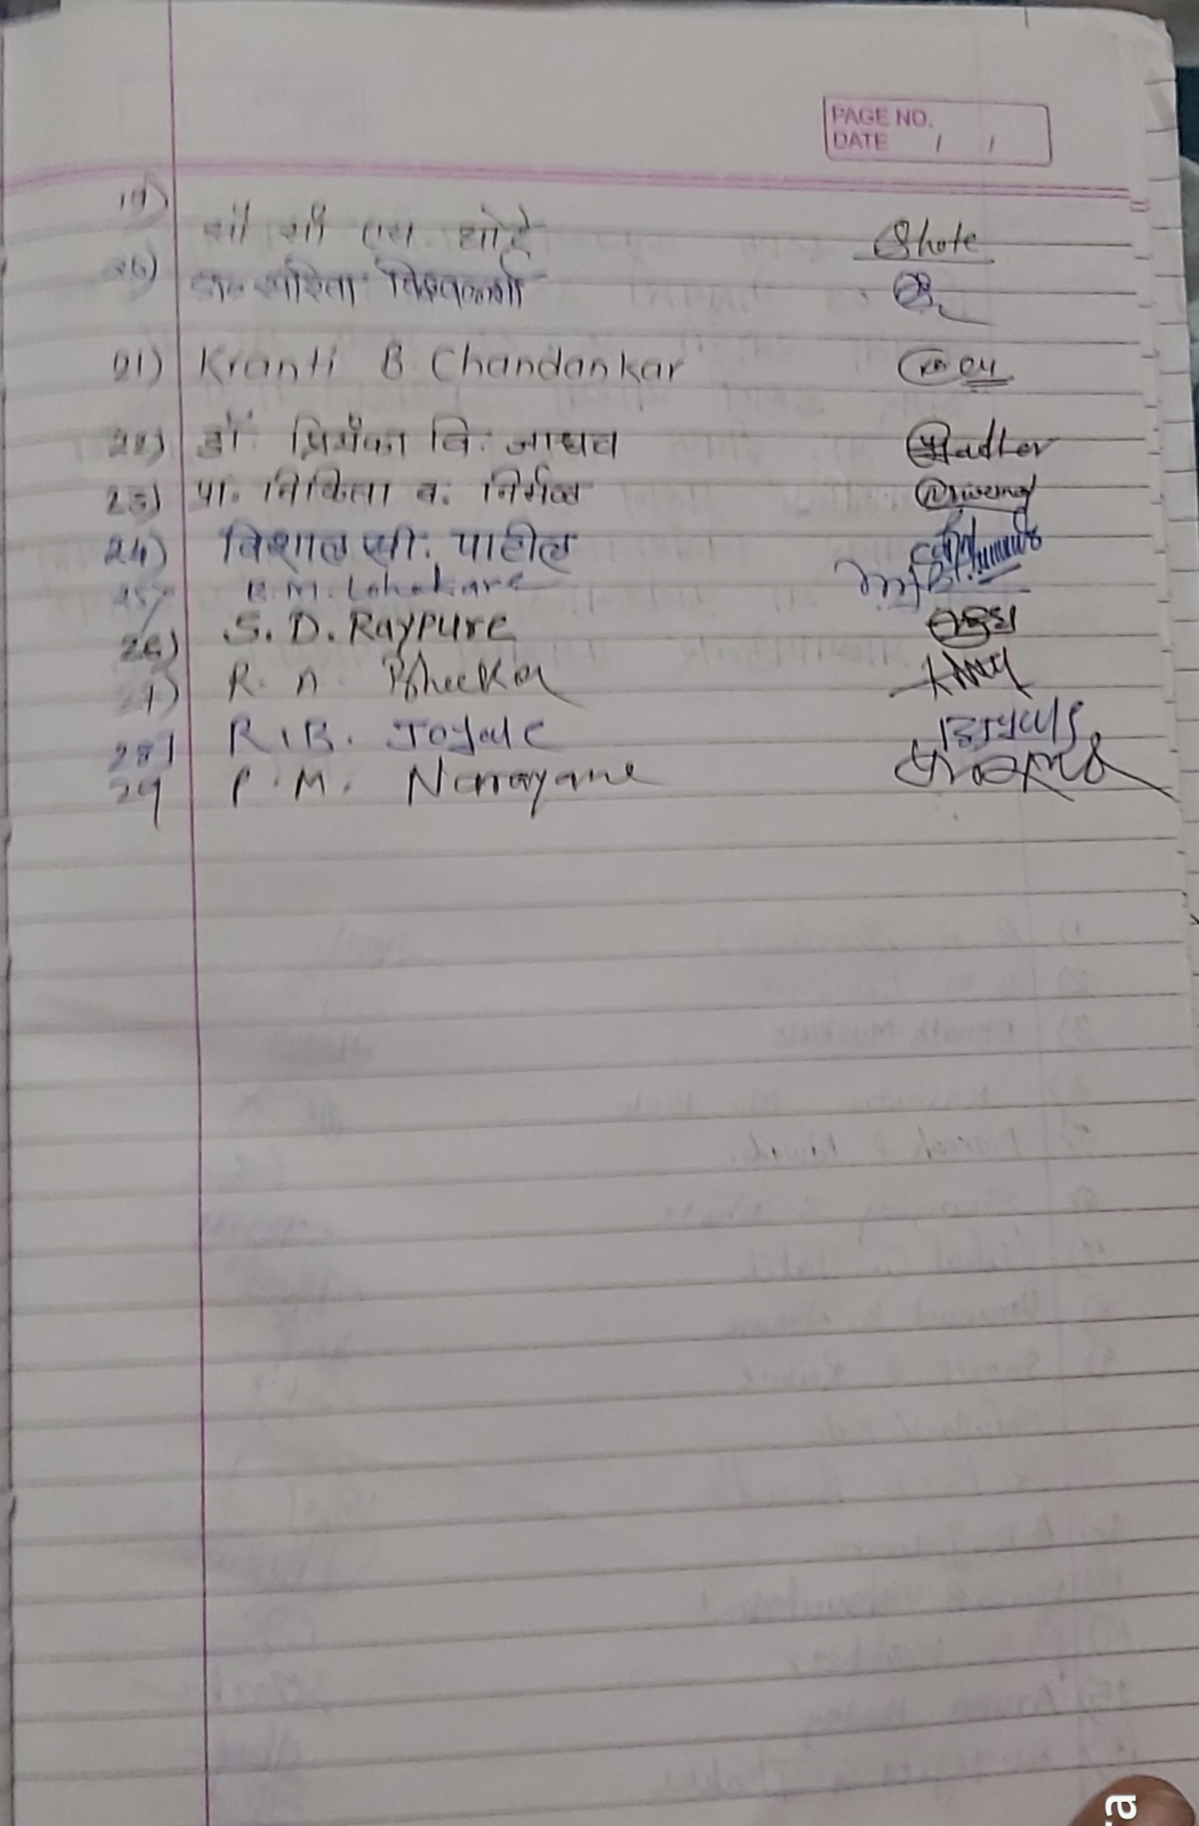

Yeshwant Mahavidyalaya, Wardha
Staff Club
Activity Organised Report
Session 2020-21

Name of the activity organized | Paper reading
Title of the Paper | Upekshit Samajatil Mahan Sant Chokhamela
Name of the paper reader | Deepak Mahajan
Date of activity organized | 03. 02. 2021
Name of the chairperson | Amar Dahane
Place of the activity | Room No. 8
Name of the co-ordinator activity | Prof. Pramod Narayane
Objective of the Activity | To study the biography of Sant Chokhamela  To understand the socio, political , Economicaly, Spititual senirio of Maharashtra in chokkhamela era  To determine the Birth Place of Sant Chokhamela  To understand the work of Sant Chokhamela
Outcome of the activity | Staff Members are come to know about the biography of Sant Chokamela  Staff are come to know about the socio, political , Economicaly, Spititual senirio of Maharashtra in chokkhamela era  Staff members understood the work of Sant Chokhamela
No. of participation (Staff) | 31
Photo and News | Attached
Signature sheet of Staff | Attached
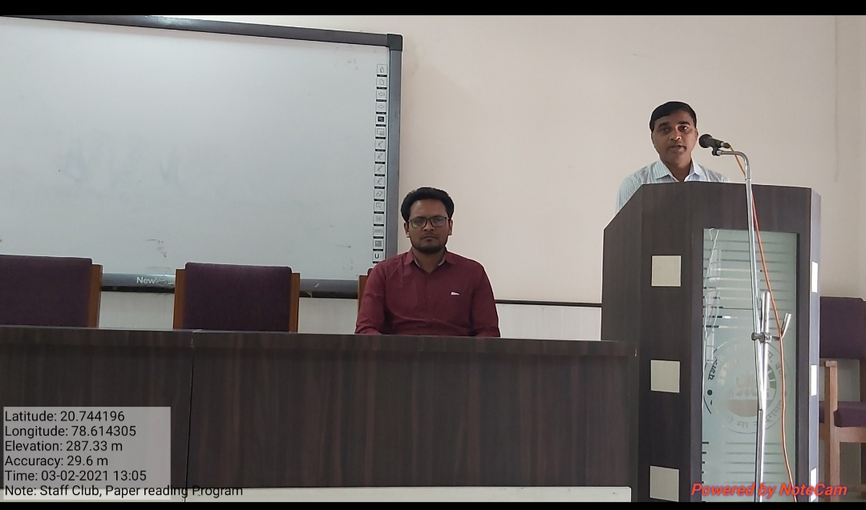
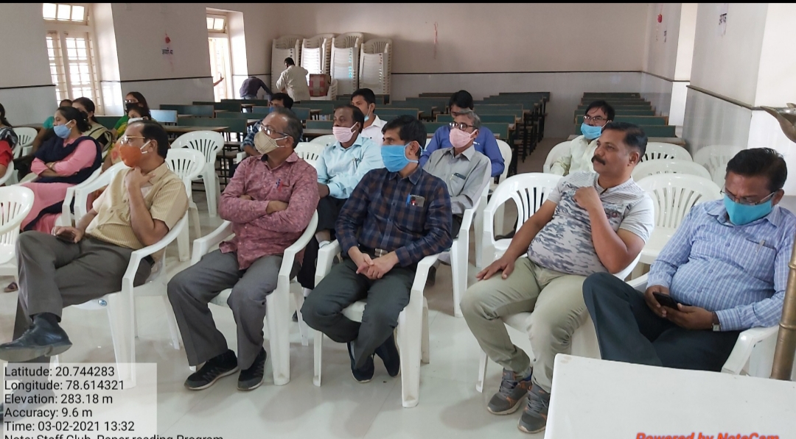
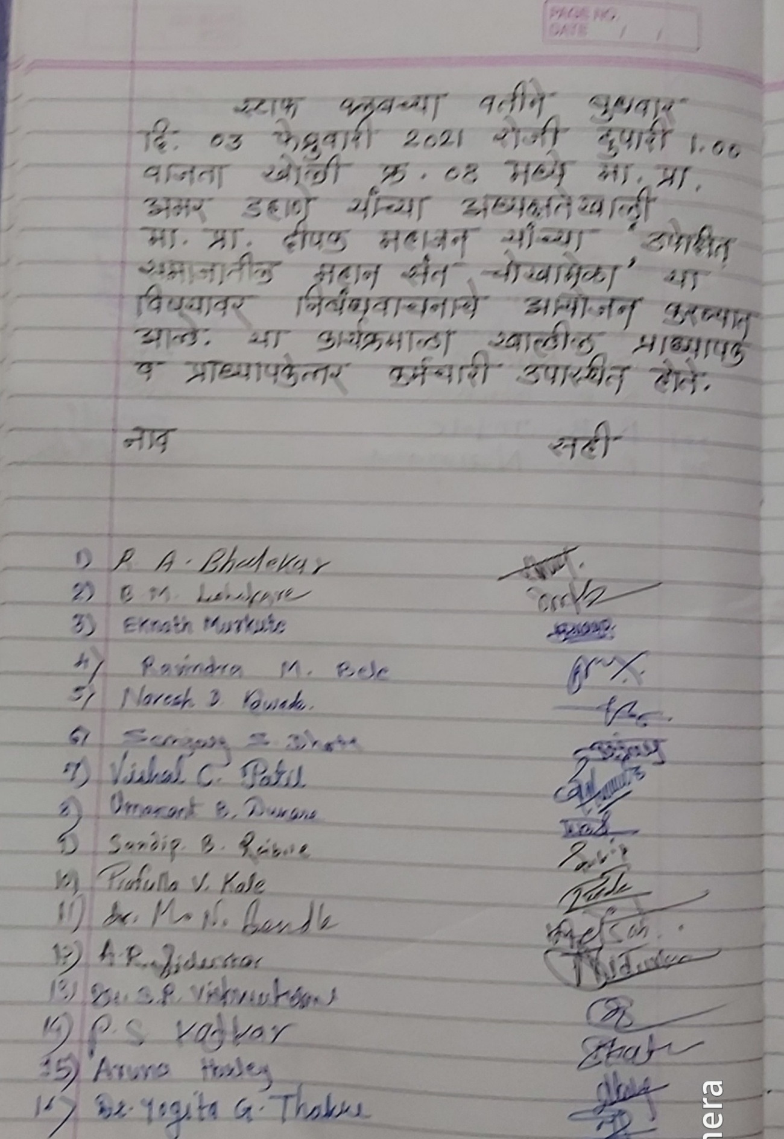
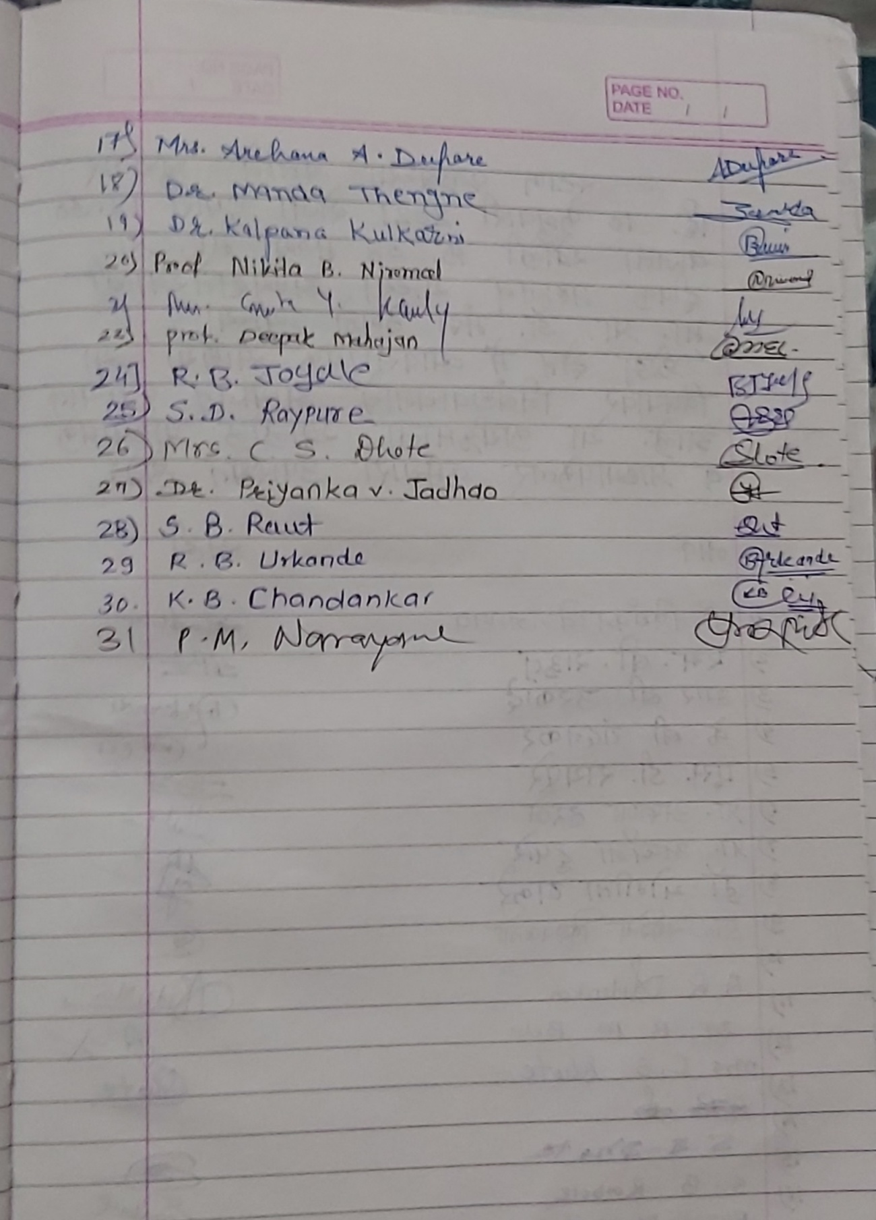

Yeshwant Mahavidyalaya, Wardha
Staff Club
Activity Organised Report
Session 2020-21

Name of the activity organized | Paper reading
Title of the Paper | Krida Kshetra Me Vyavsahik Sandhiya
Name of the paper reader | Manda Thengane
Date of activity organized | 10. 02. 2021
Name of the chairperson | Deepak Mahajan
Place of the activity | Room No. 8
Name of the co-ordinator activity | Prof. Pramod Narayane
Objective of the Activity | To create awareness about the career in sport  To provide the guidance about the course available in sports as a career  To provide information about the institution in India
Outcome of the activity | Students are motivated to choose sports fild as o career  Students are come to know about the importance of game and sports in their life
No. of participation (Staff) | 24
Photo and News | Attached
Signature sheet of Staff | Attached
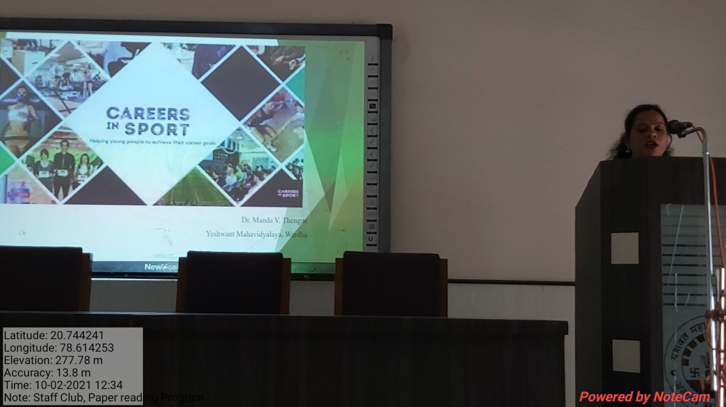
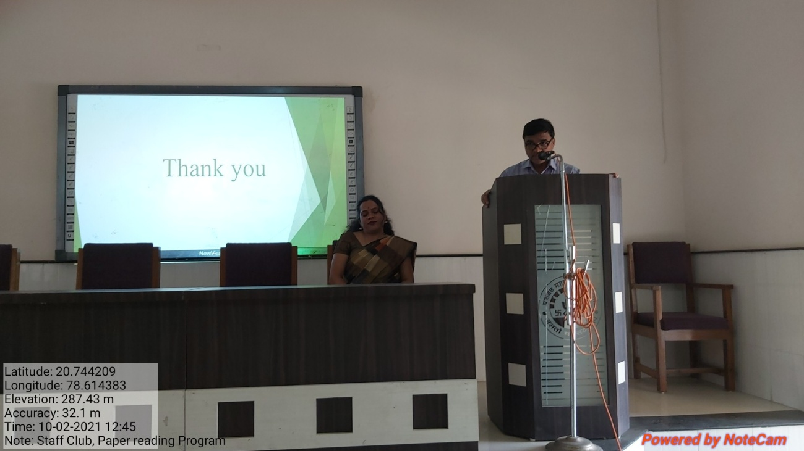
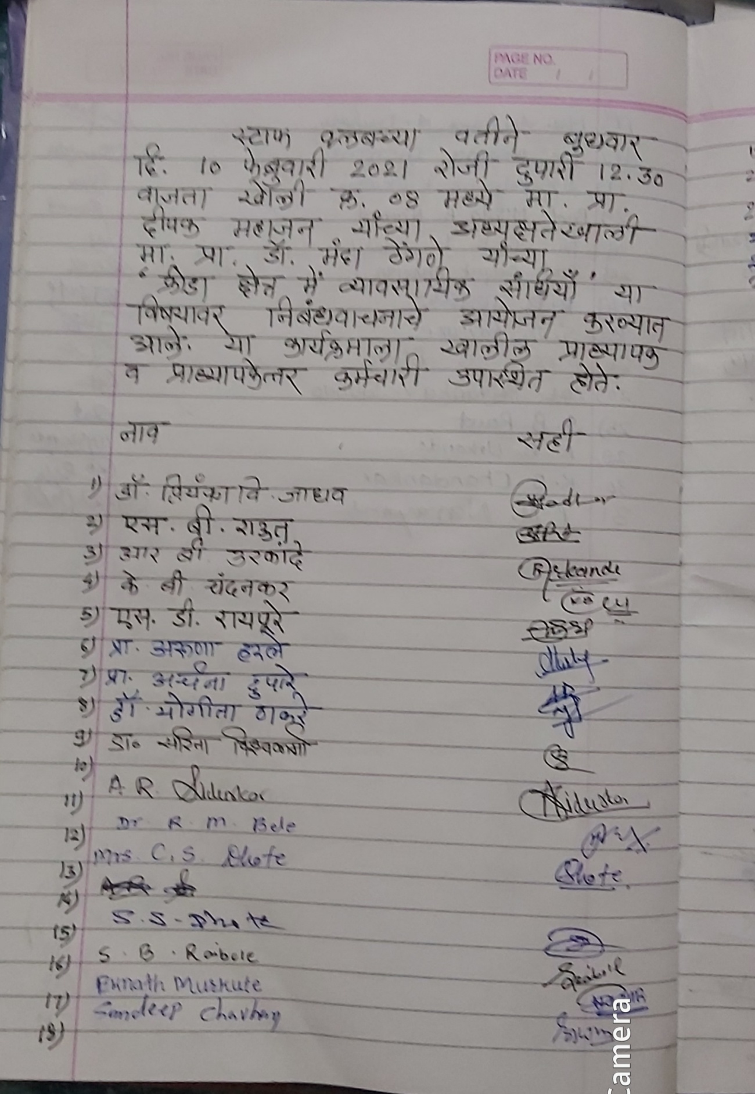
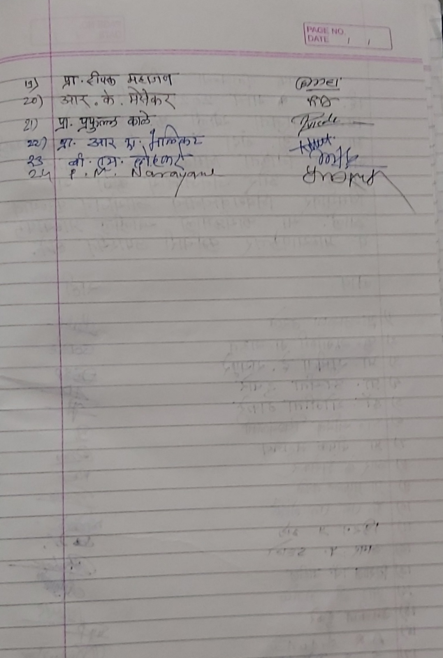

Yeshwant Mahavidyalaya, Wardha
Staff Club
Activity Organised Report
Session 2020-21

Name of the activity organized | Paper reading
Title of the Paper | Moukhik Sanskriti Aur Janjatiya Kala
Name of the paper reader | Nikita Nirmal
Date of activity organized | 03. .3. 2021
Name of the chairperson | Dr. Manda Thengane
Place of the activity | Room No. 8
Name of the co-ordinator activity | Prof. Pramod Narayane
Objective of the Activity | Exploring the oral culture found in the tribal arts  Find out the variety in oral culture  Cultivate oral culture through the tribal art.
Outcome of the activity | The oral culture found in tribal in tribal art was explored  Oral culture of tribal art having big asset various culture  Tribal art prevented the oral culture and It’s old traditions
No. of participation (Staff) | 27
Photo and News | Attached
Signature sheet of Staff and students | Attached
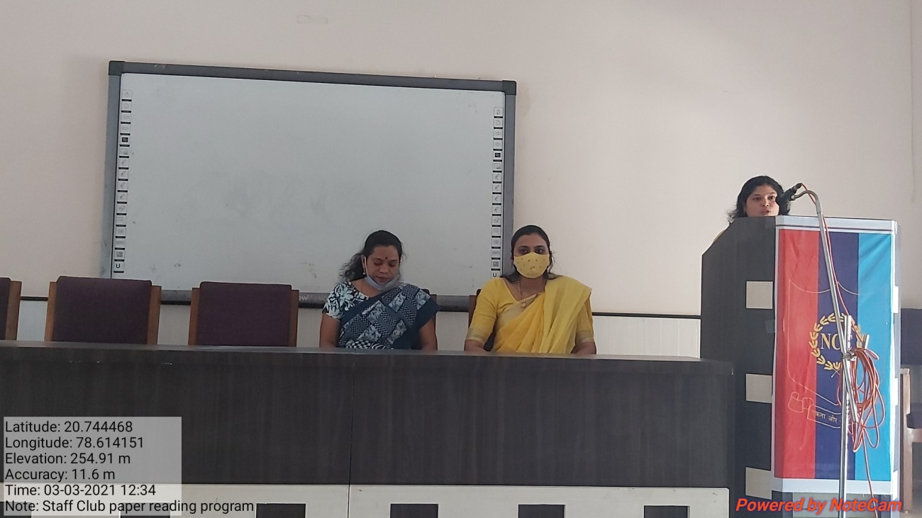
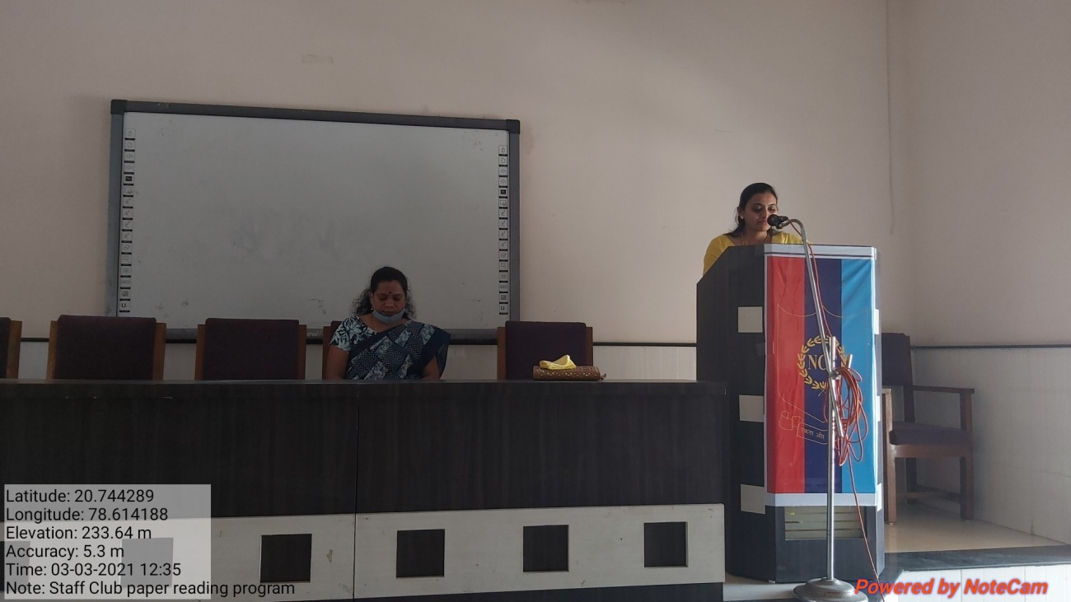
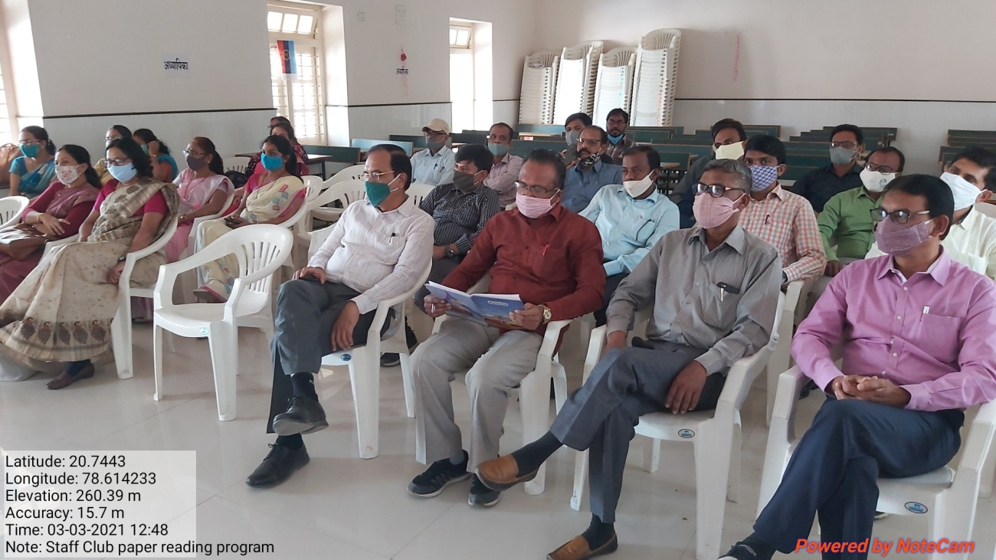
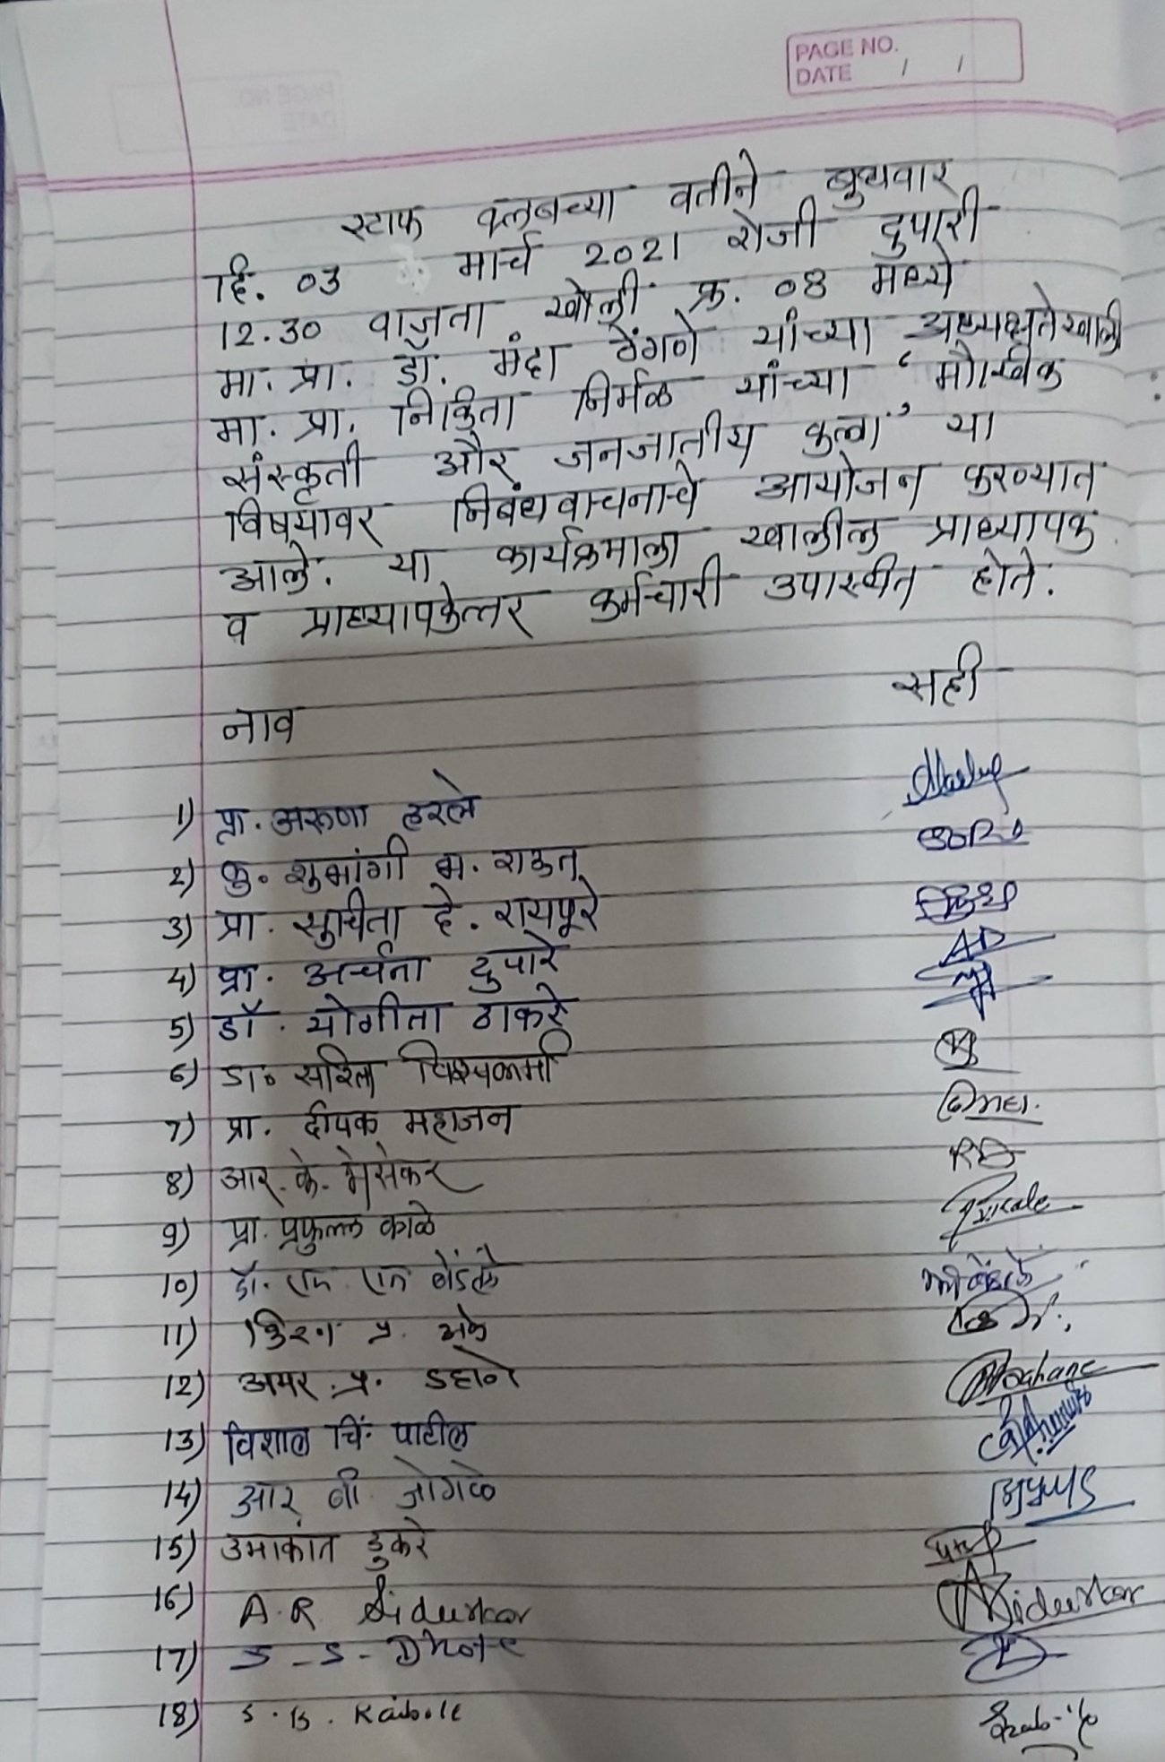
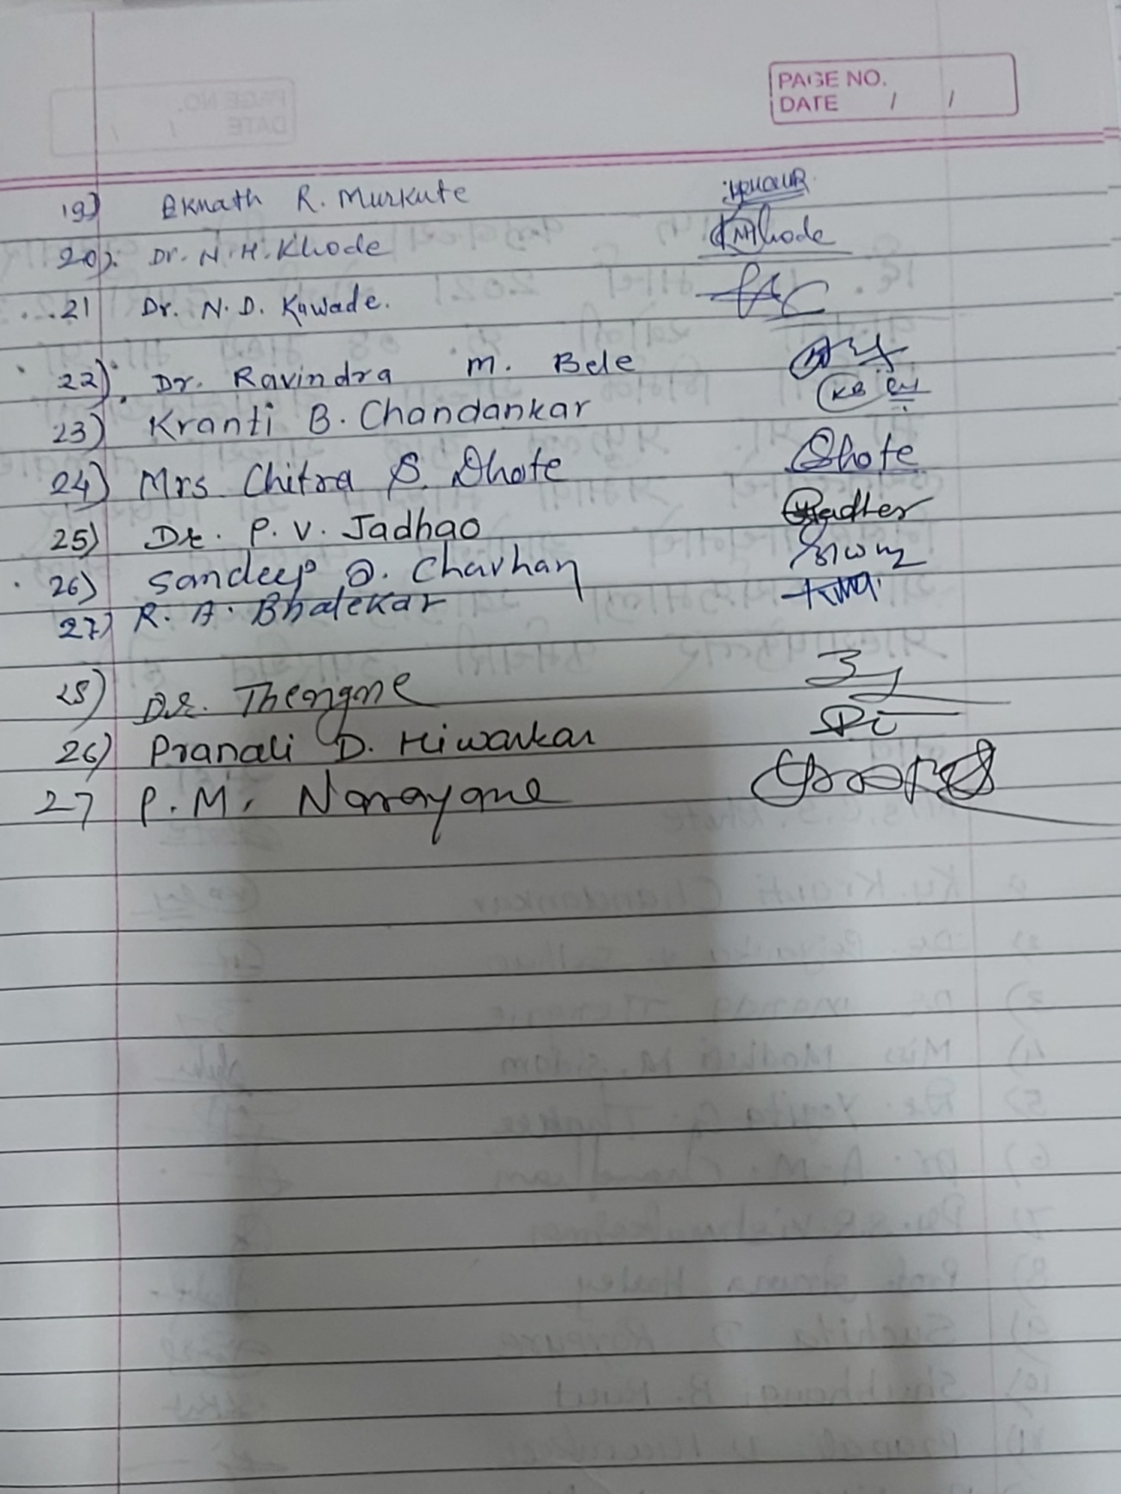

Yeshwant Mahavidyalaya, Wardha
Staff Club
Activity Organised Report
Session 2020-21

Name of the activity organized | Paper reading
Title of the Paper | Talvadya : Layatatwache Prabhavi Madhyam
Name of the paper reader | Prafulla Kale
Date of activity organized | 10. 03. 2021
Name of the chairperson | Nikita Nirmal
Place of the activity | Room No. 8
Name of the co-ordinator activity | Prof. Pramod Narayane
Objective of the Activity | To understand what Laytatva is  To understand the definition, structure, types and use of Percussion Instruments.  To study the socio- musical relationship between Laytatva and Percussion Instruments.  To study the interrelationship between Laytatva and living things.
Outcome of the activity | Laytatva studied that it resides in the universe.  Taking a detailed look at the percussion instrument and its various types and their use  Laytatva and Percussion Insruments studied form a socio-Musical point of view.  Explained the interrelationship between the rhythm and the human body and encouraged them to harmonize with each other
No. of participation (Staff) | 29
Photoes | Attached
Signature sheet of Staff | Attached
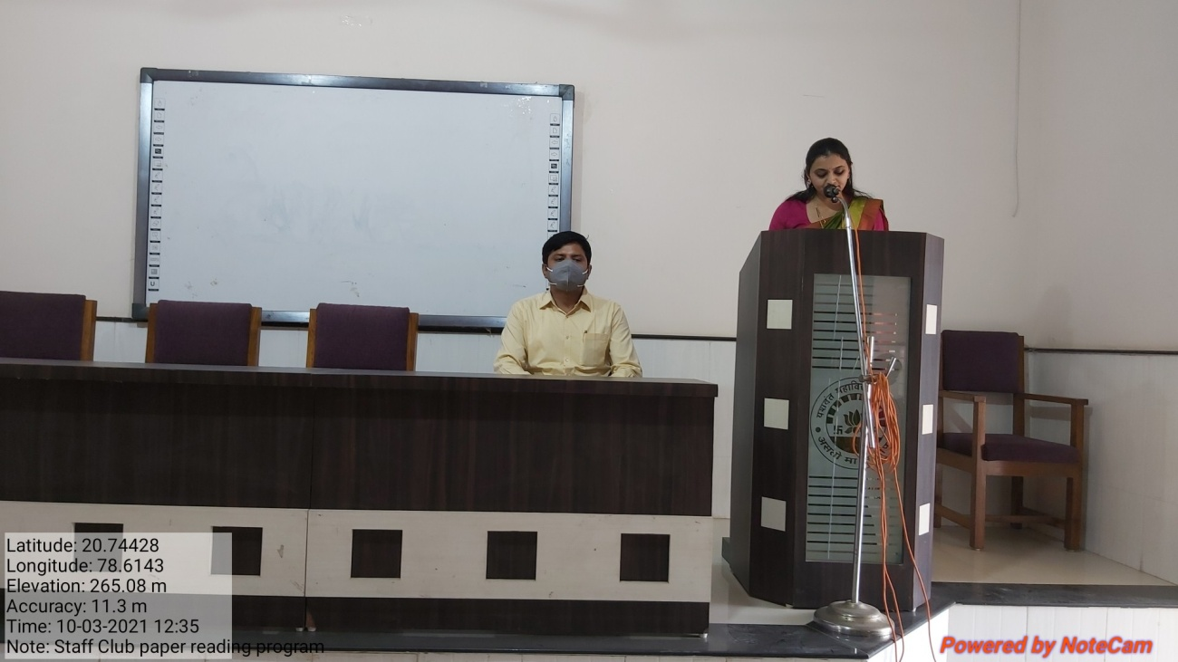
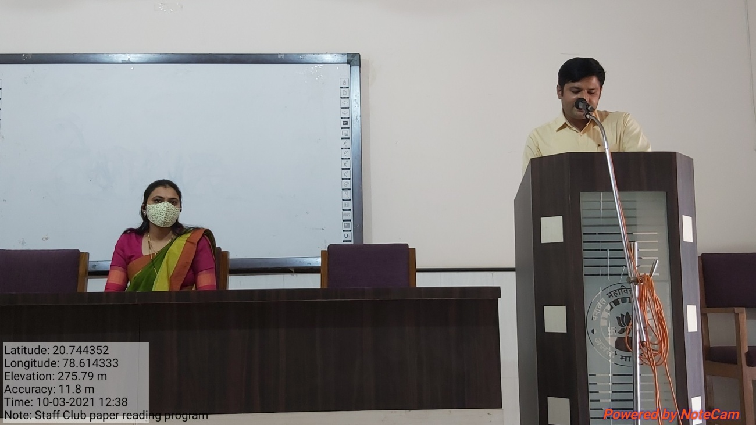
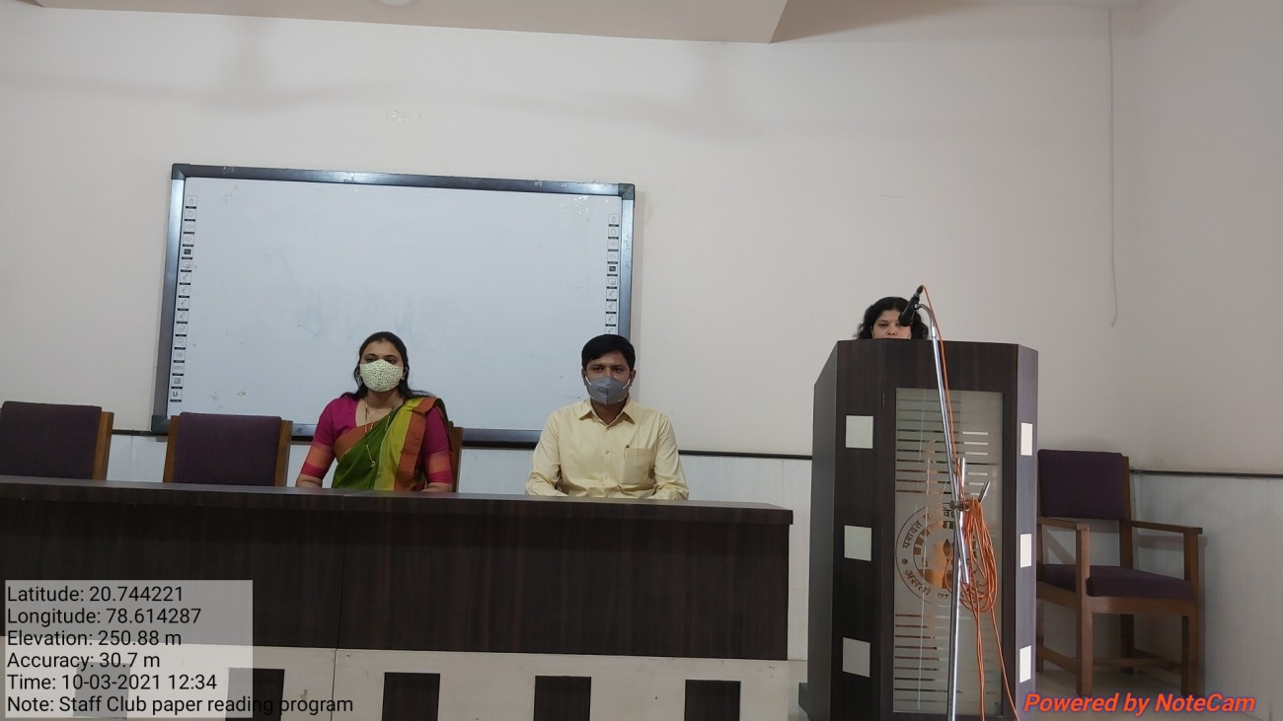
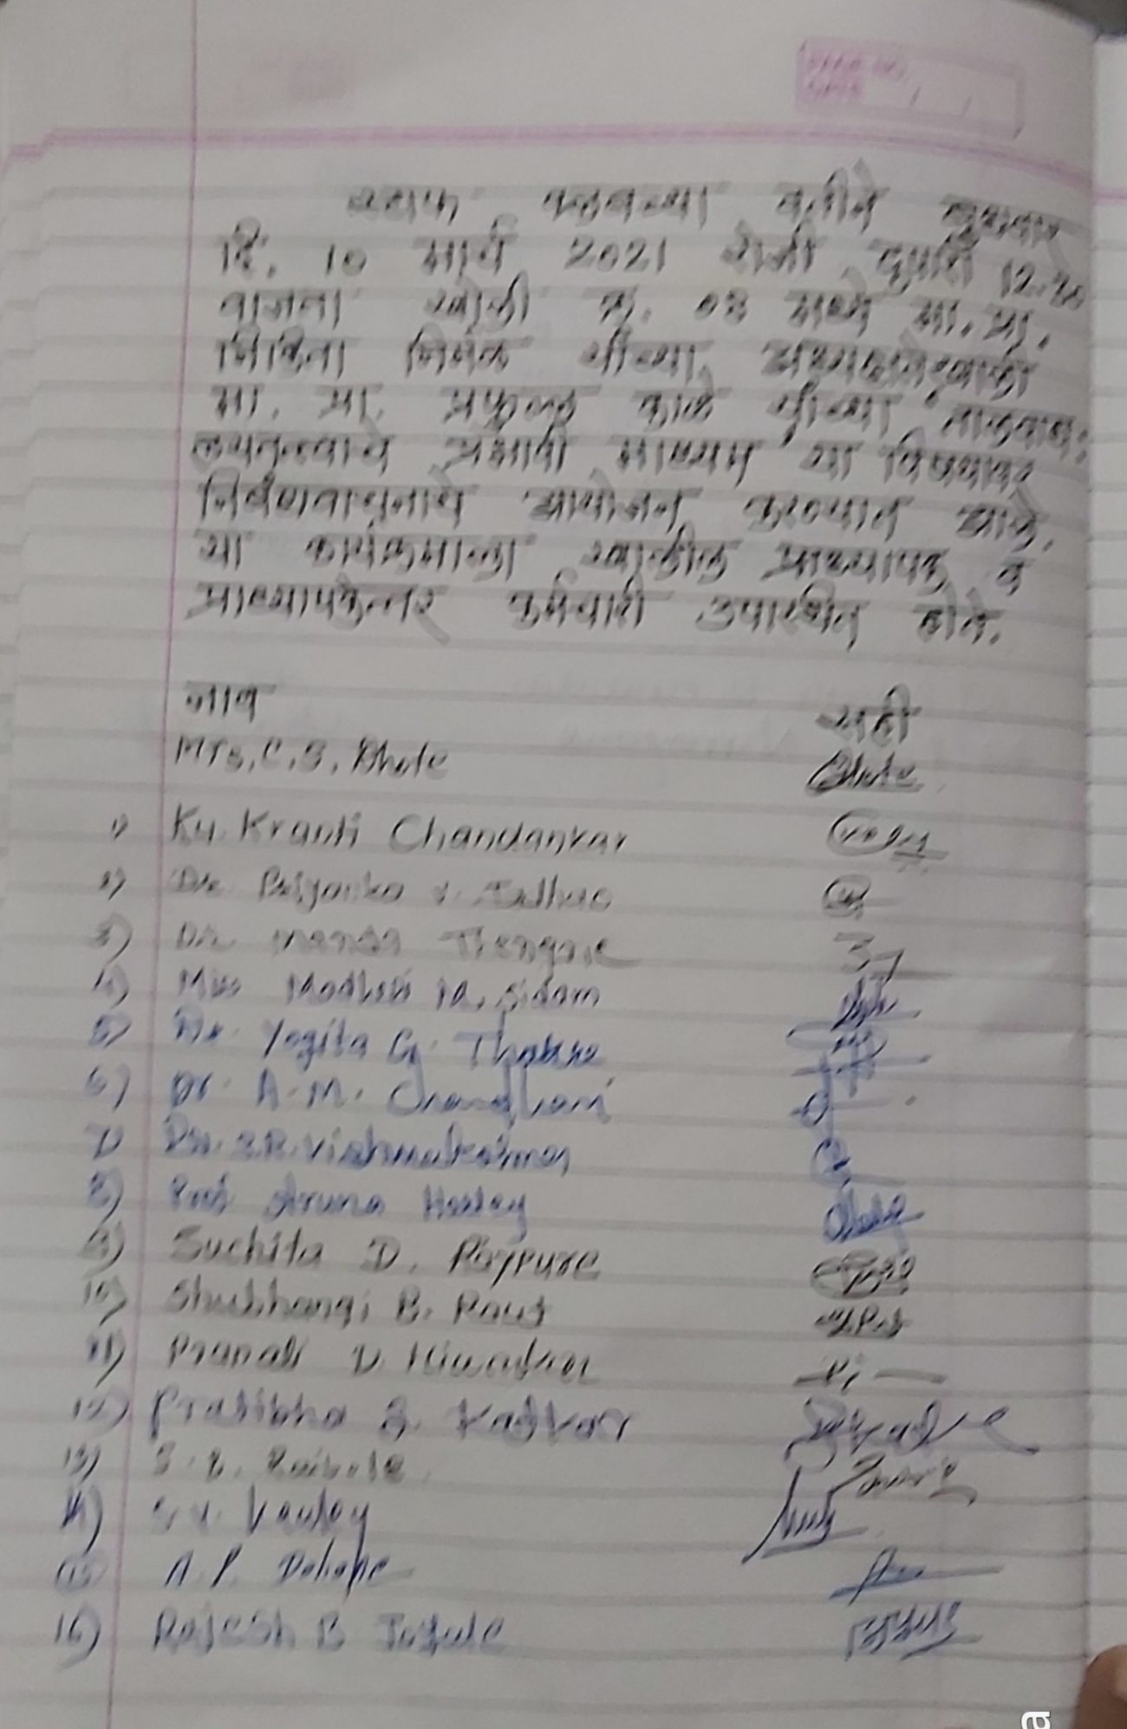
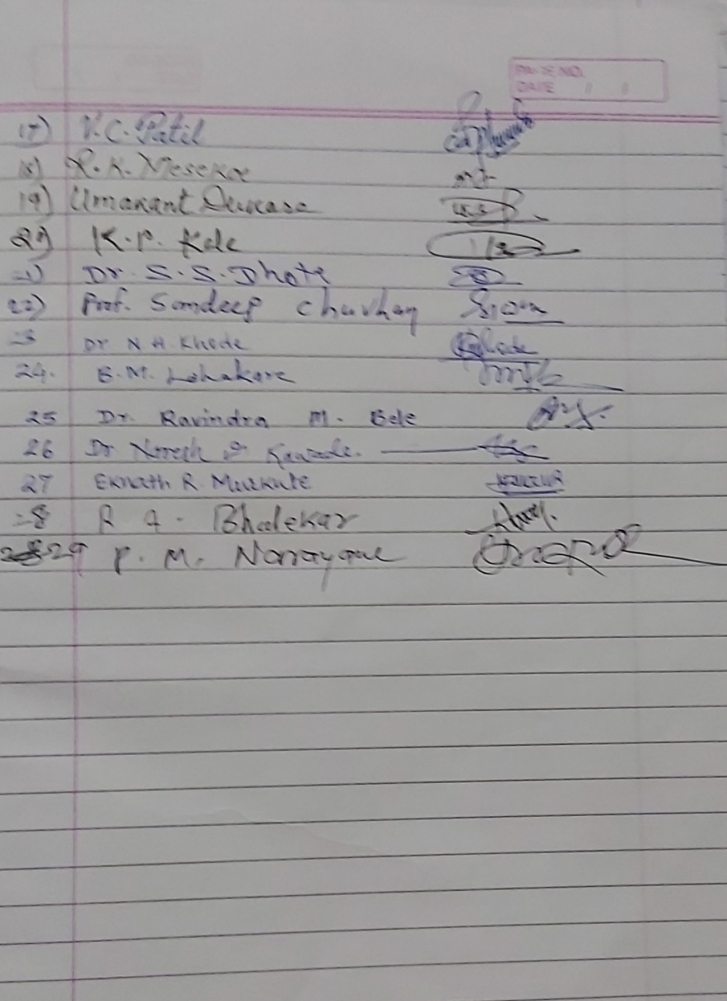
Best Practice - II

Title of the practice :- Yeshwant Scholarship

Goal :- The objectives in starting this practice were as follow:
- To attract more admission flow.
- To attract meritorious students of H.S.C. to join our institution.
- To help students financially so that they can purchase books and reading material.
- To receive this scholarship, attendance is compulsory; hence it would not only improve the attendance, but would also boost their confidence and act as a motivational factor in their academic pursuits.
- This scholarship is open to all irrespective of caste, category or financial status of parents.

Context:-Students coming to our institution are from the rural areas. Many of them work as labourers in the fields. They suffer financial crisis and hence they are not regular in their classes. Hence, the Principal, the teaching and non- teaching faculty and the retired faculty of the college came together and decided to raise a corpus fund with the help of which the students would be benefitted.

Practice: - The teaching faculty voluntarily decided to contribute Rs. 500/- and the non-teaching faculty Rs. 100/- per month for the fund from the year 2011. The retired staff has also contributed Rs. 10,000/-each as seed money for the corpus fund to the tune of Rs.3.04000. As a result, we have been able to bring students out of financial crisis. This endeavour has not only increased the student flow, but also the attendance of the students. The table given below clearly indicates the number of students benefitted by this practice and the amount spent, apart from the government scholarship the students get. Moreover, these meritorious students have come in contact with the scholarship disbursing committee which gives personal attention to them and motivates them to perform better. They can have a face-to-face interaction with the committee members where they can speak about their problems. The committee members take steps to find solution to their problems. Moreover, the committee members also suggest reference books for their further reading so as to enhance their personality.

With the inception of this practice, we have been able to cover even those students who are not covered under the government scholarship. The scholarship has boosted the morale of the students and motivated them to do better in their academic pursuit and has ultimately aroused their interest in studies. Automatically, the percentage of attendance in such classes has also gone up. Cut-off percentage of marks gone up.

Problems: - Today, we do not have any problem in raising this fund, and the teaching and non-teaching faculty take pride for having helped the students in this manner. Apart from this, the faculty of Home Science Department raises a fund in order to help the needy students to provide them fees of admission, exam fees, recharge of mobile during pandemic .

